# 

# 



**Droid Scanner: App Security Management System**

**SE- 505: Software Project Lab - 2**

# 

**Submitted by**

Md. Shaikhul Islam (BSSE 1438)

Salsabila Zaman (BSSE 1443)

**Supervised by**

Prof. Md. Zulfiquar Hafiz

Institute of Information Technology

University of Dhaka

**Supervisor’s Approval:**

**Date:** 09-12-2024

**Table of Contents**

User Story : 1

QFD (Quality Function Deployment): 3

1. Use Case Diagram 4

Primary Actor: 4

Level 0: 5

Level 1: 6

Level 1.1: 7

Level 1.2 8

Level 1.2.1 9

Level 1.2.2: 10

Level 1.3 11

Level 1.4 12

2.Swimlane Diagram 13

2.1. Definition of Swimlane Diagram 13

2.2. Swimlane ID (SID) 1.1 14

2.3. Swimlane ID (SID) 1.2 15

2.3. Swimlane ID (SID) 1.2.1 16

2.4. Swimlane ID (SID) 1.2.2 17

2.5. Swimlane ID (SID) 1.3 18

2.6. Swimlane ID (SID) 1.4 19

3.Data Based Modeling 20

3.1. Definition of Database Diagram 20

3.2. Data Objects Identification: 20

3.3. Final Data Objects: 24

3.4. Relationship between Objects: 24

3.5. Entity Relation ( ER ) Diagram: 25

3.6. Schema Diagram: 26

4.CLASS-BASED MODELING 27

4.1. CLASS BASED MODELING CONCEPT: 27

4.2. General Classification: 27

4.3. Noun List: 28

4.4. Verb List: 31

4.5. Selection Criteria: 33

4.6. Analysis: 34

4.7. Class Cards 35

4.7. CRC Diagram: 40

5.Behavioral Modeling 41

5.1. Definition of Behavioral Modeling : 41

5.2. Lists of events: 41

5.3 State Transition Diagram 43

5.3.1. ID: 1: Authentication 43

5.3.2. ID: 2: Android Device User 44

5.3.3. ID: 3: Android App Developer 45

5.3.4. ID: 4: App 46

5.3.5. ID: 5: Scan 46

5.3.6. ID: 6: Report 47

5.3.7. ID: 7: ML Model 47

5.3.8. ID: 8: Notification 48

5.3.9. ID: 9: Dashboard 48

5.3.10. ID: 10: Database 49

6.Sequence Diagram 49

6.1. Concept of Sequence Diagram : 49

**List Of Figures**

Figure 0: ASMS 5

Figure 1: ASMS(Detailed) 6

Figure 1.1: Authentication 7

Figure 1. 2: Malicious App Detection 8

Figure 1.2.1: Scan 9

Figure 1.2.2: APK Analysis 10

Figure 1.3: Custom App Management 11

Figure 1.4: Report Generation 12

Figure: SID 1.1 14

Figure: SID 1.2 15

Figure: SID 1.2.1 16

Figure: SID 1.2.2 17

Figure: SID 1.3 18

Figure: SID 1.4 19

Figure 3: Entity Relation ( ER ) Diagram 25

Figure 4: CRC Diagram 40

Figure 5.1: Authentication 43

Figure 5.2: Android Device User 44

Figure 5.3: Android App Developer 45

Figure 5.4: App 46

Figure 5.5: Scan 46

Figure 5.6: Report 47

Figure 5.7: ML Model 47

Figure 5.8: Notification 48

Figure 5.9: Dashboard 48

Figure 5.10: Database 49

Figure 6: Sequence Diagram 50

**Software Requirement Specification report of**

**“Droid Scanner: App Security Management System”**

# User Story :

The **Droid Scanner: App Security Management System** is designed as a robust software solution, safeguarding android devices from potential threats and ensuring high-security standards for app development.

This system serves two primary stakeholder groups: **Android Device Users**, who prioritize device security, and **Android App Developers**, who need tools to ensure their apps are free from vulnerabilities and comply with privacy standards.

The software provides flexible scan options, offering a **Full Scan** : A comprehensive scan of all the installed apps and a **Quick Scan** : scan a particular App on command. All the forms ensure security monitoring.

For Android Device Users, the system operates as a personal security tool. Users initiate the setup by accessing their dedicated User Dashboard, which displays the user profile, previous scans history, and black & white applists. The system's Malicious App Detection feature performs in-depth scans to identify harmful apps by analyzing APK files. The APK Extraction feature allows users to save or examine APK files. With the Custom App Management feature, users can whitelist trusted apps to avoid redundant checks and blacklist risky apps. All scans and their outcomes are stored securely in a User Database, which enables easy access to past reports, scan summaries, helping users stay informed about potential risks and ensure data privacy.

For Android App Developers, the system serves as an essential security and compliance tool to evaluate and improve app safety before launch. Developers access a dashboard that enables them to view scan reports. The system’s APK Extraction and Permissions tools let developers save and review copies of their apps, making sure permissions like location or camera are only used when necessary. The Permission Viewer shows every permission request in detail, helping developers easily choose which to keep or remove for better user privacy. After each scan, the system generates a comprehensive report detailing **app details, permissions used, intents, security status, feature analysis, helping developers align their app with industry standards**. Additionally, each developer has access to a secure User Database where all detected issues, past scans, and security records are stored, ensuring a traceable history for continuous improvement and compliance.

Through the App Security Management System, both primary users and developers receive vital, tailored software for device protection and app security. The platform’s streamlined dashboards, customizable scan options, in-depth reports, and centralized database empower users to maintain data integrity and developers to release trustworthy, compliant applications that prioritize user security and privacy.

# QFD (Quality Function Deployment):

QFD, or Quality Function Deployment, is a structured approach used in product development and project management. It helps ensure that customer needs and expectations are translated into specific product or service features. Essentially, it's a way to bridge the gap between what customers want and what a company delivers. QFD involves capturing customer requirements, prioritizing them, and then aligning internal processes to meet those requirements efficiently. It's like a roadmap for turning customer desires into tangible results.

**Normal:**

1. The application will feature a user-friendly dashboard that consolidates all functionalities for ease of access.
2. Users will have the ability to update and edit their profiles.
3. The system will enable users to analyze APK files to extract the features utilized by the respective applications.
4. Users can review the history of their previous scans

**Expected:**

1. APK file can be uploaded
2. Malicious apps would get detected

**Exciting:**

1. Multiple Scan Options: Full scan for scanning all apps in the device, quick scan for a single or fewer apps.
2. Custom App Management: Whitelist for trusted apps, blacklist for risky ones, and this would be done by the choice of the users.

# 

# 

# 1. Use Case Diagram

A Use Case describes the system behavior under various conditions as the system responds to a request from one of its stakeholders. In fact, a use case diagram is a kind of visualization of the system where an end-user has an idea of a specific feature. It simply describes a story using corresponding actors who perform important roles in the story and make the story understandable for the users.

The first step in writing a Use Case is to define the set of “actors” that will be involved in the story. Actors are the different people or systems that use the system or product within the context of the function and behavior that is to be described. Actors represent the roles that people play as system operators. They procedure some information or consume some information. Every user has one or more goals when using the system.

**Primary Actor**

Primary actors interact directly to achieve the required system function and derive the intended benefit from the system. They work directly with the software. They produce some information and consume some information too.

**Secondary Actor**

Secondary actors support the system so that primary actors can do their work. They either produce or consume information.

Here is the use case diagram to observe the non-technical view of the

System.

**Actors:**

· Android Device Users

· Android App Developers

## Primary Actor:

· Android Device Users

· Android App developers

## Level 0:

**Name: ASMS**

Primary Actor: Android device users, Android app developers

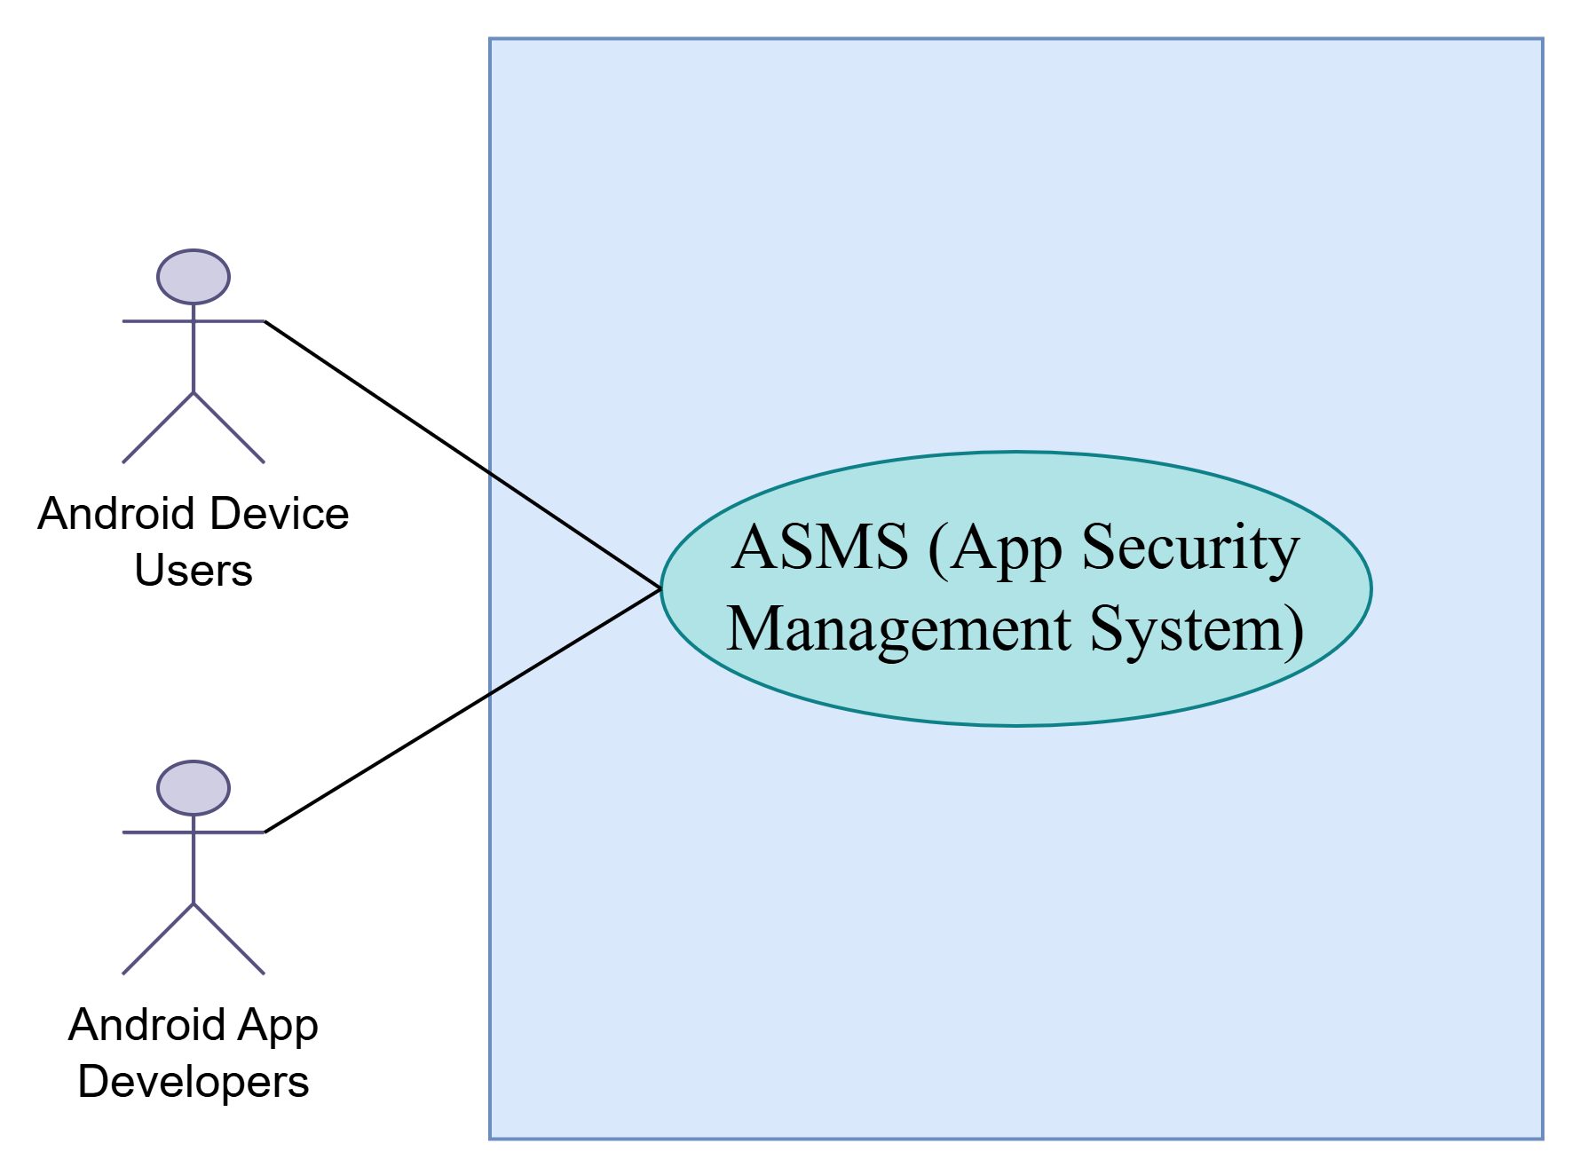

Figure 0: ASMS

## 

## Level 1:

**Name:** **ASMS(Detailed)**

Primary Actor: Android device users, Android app developers

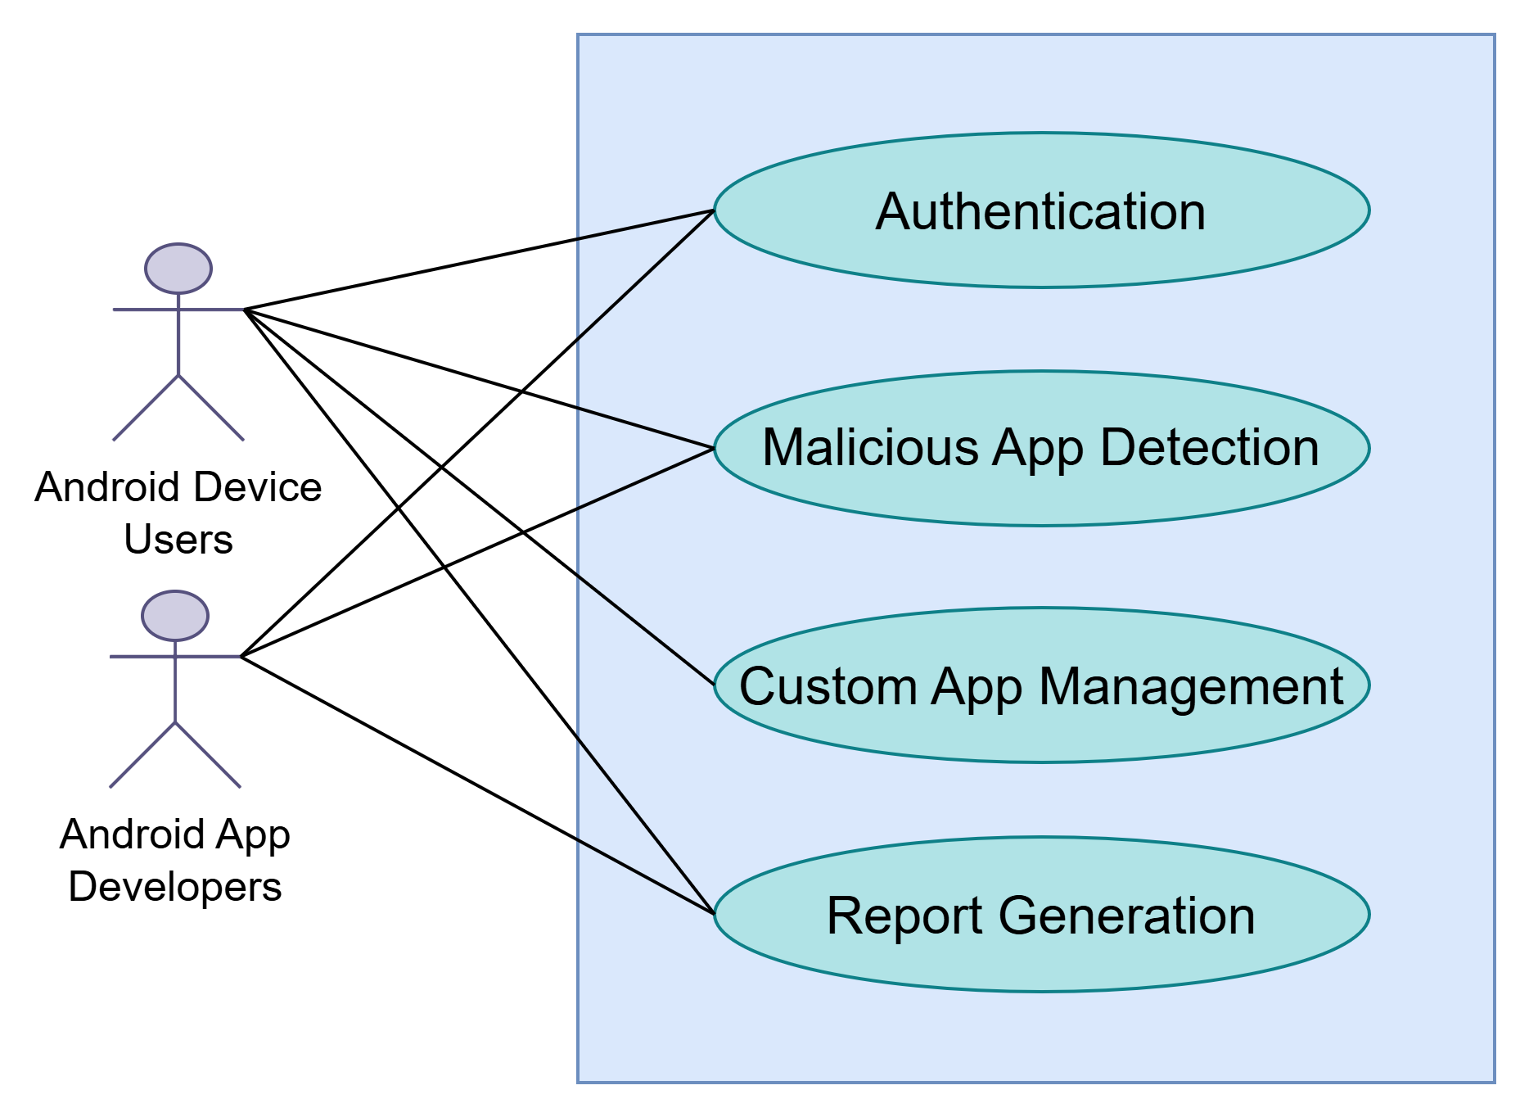

Figure 1: ASMS(Detailed)

## Level 1.1:

**Name:** **Authentication**

Primary Actor: Android device users, Android app developers

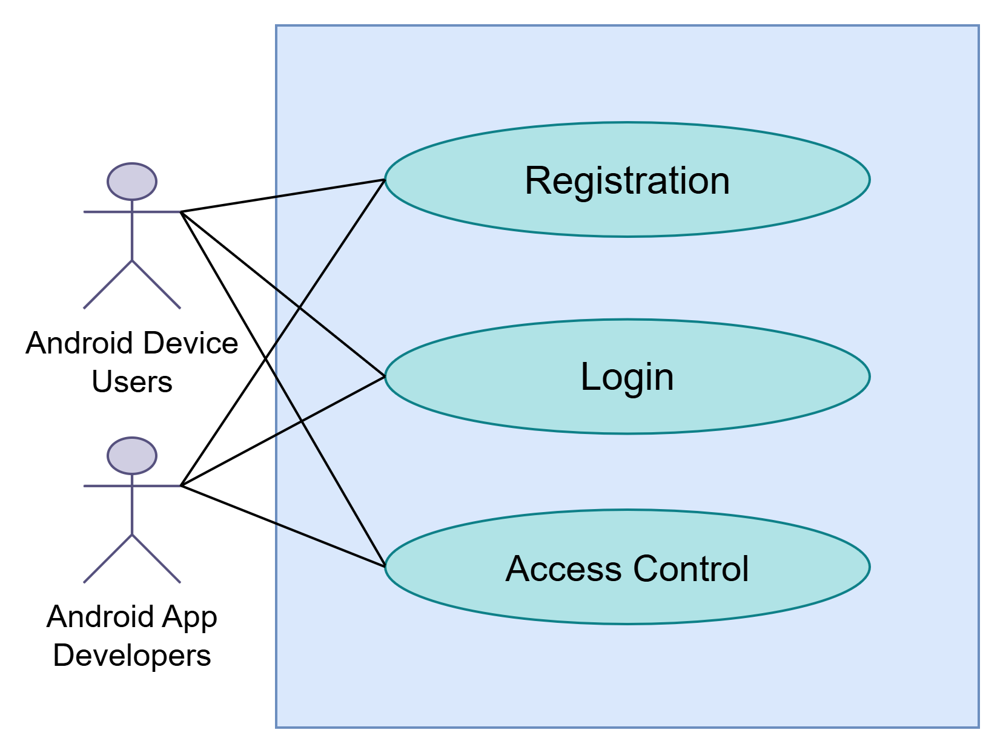

Figure 1.1: Authentication

## Level 1.2

**Name: Malicious App Detection**

Primary Actor: Android device users, Android app developers

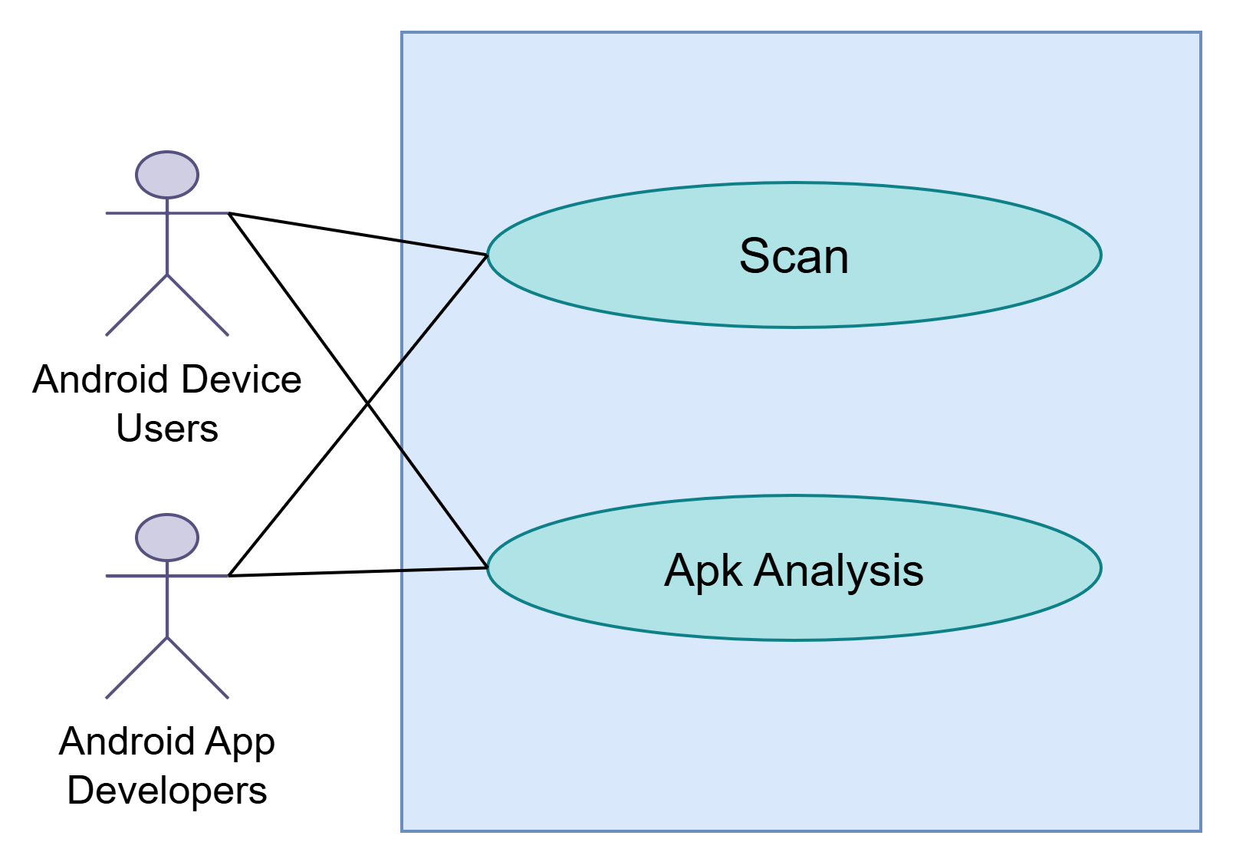

Figure 1.2: Malicious App Detection

### Level 1.2.1

**Name: Scan**

Primary Actor: Android device users, Android app developers

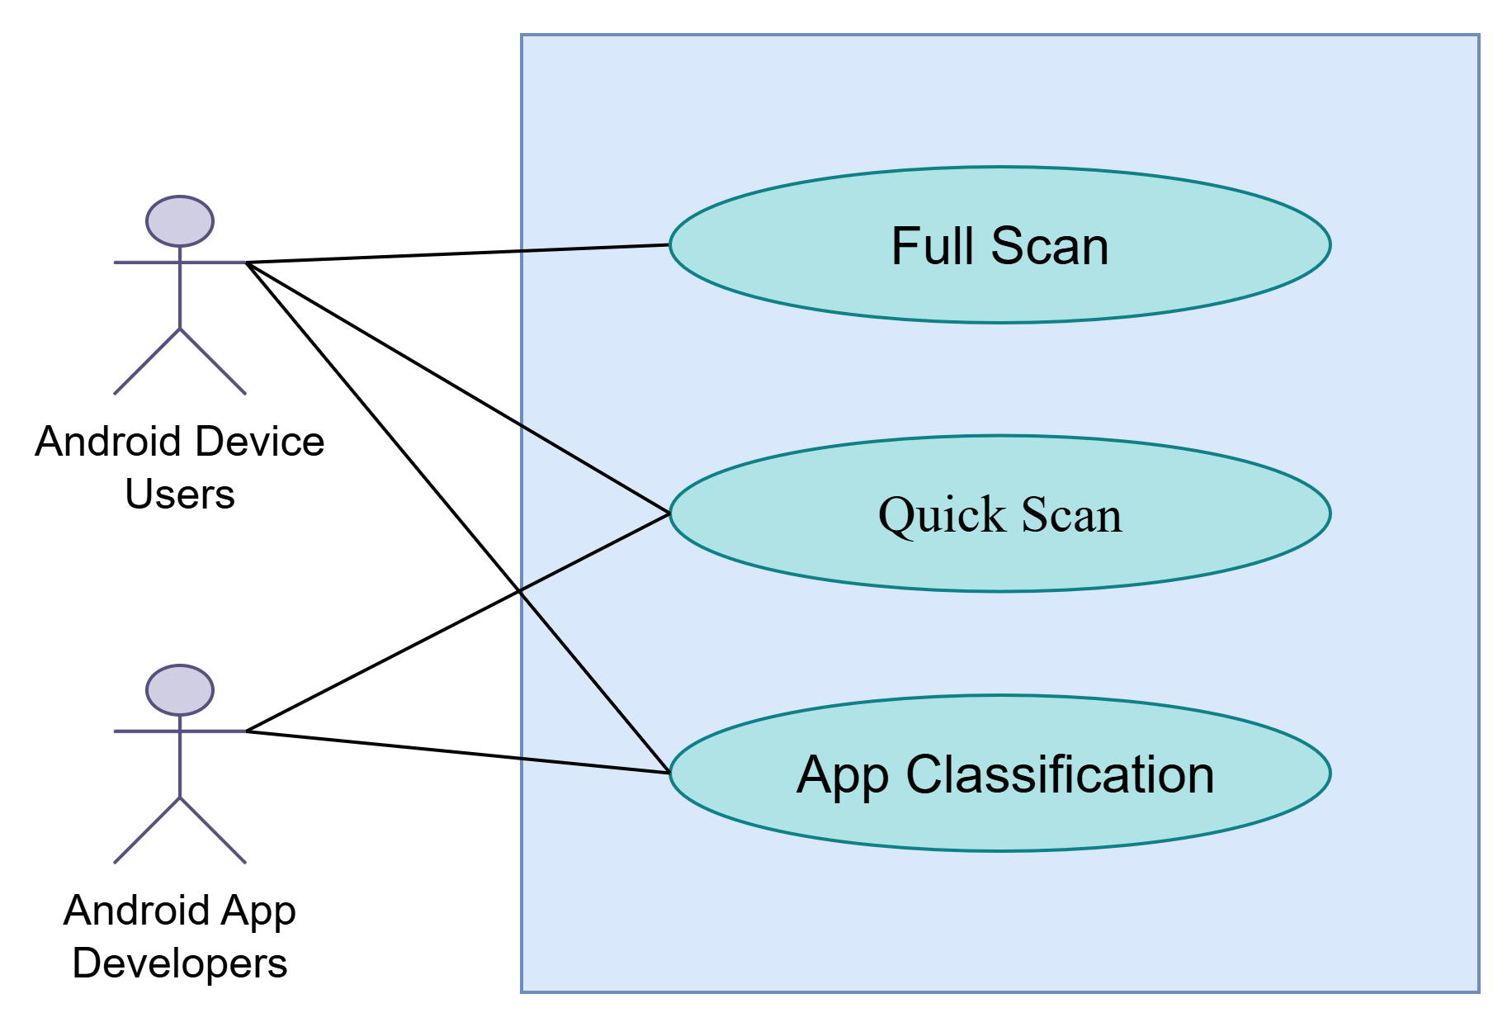

Figure 1.2.1: Scan

### Level 1.2.2:

**Name: APK Analysis**

Secondary Actor: Android device users, Android app developers

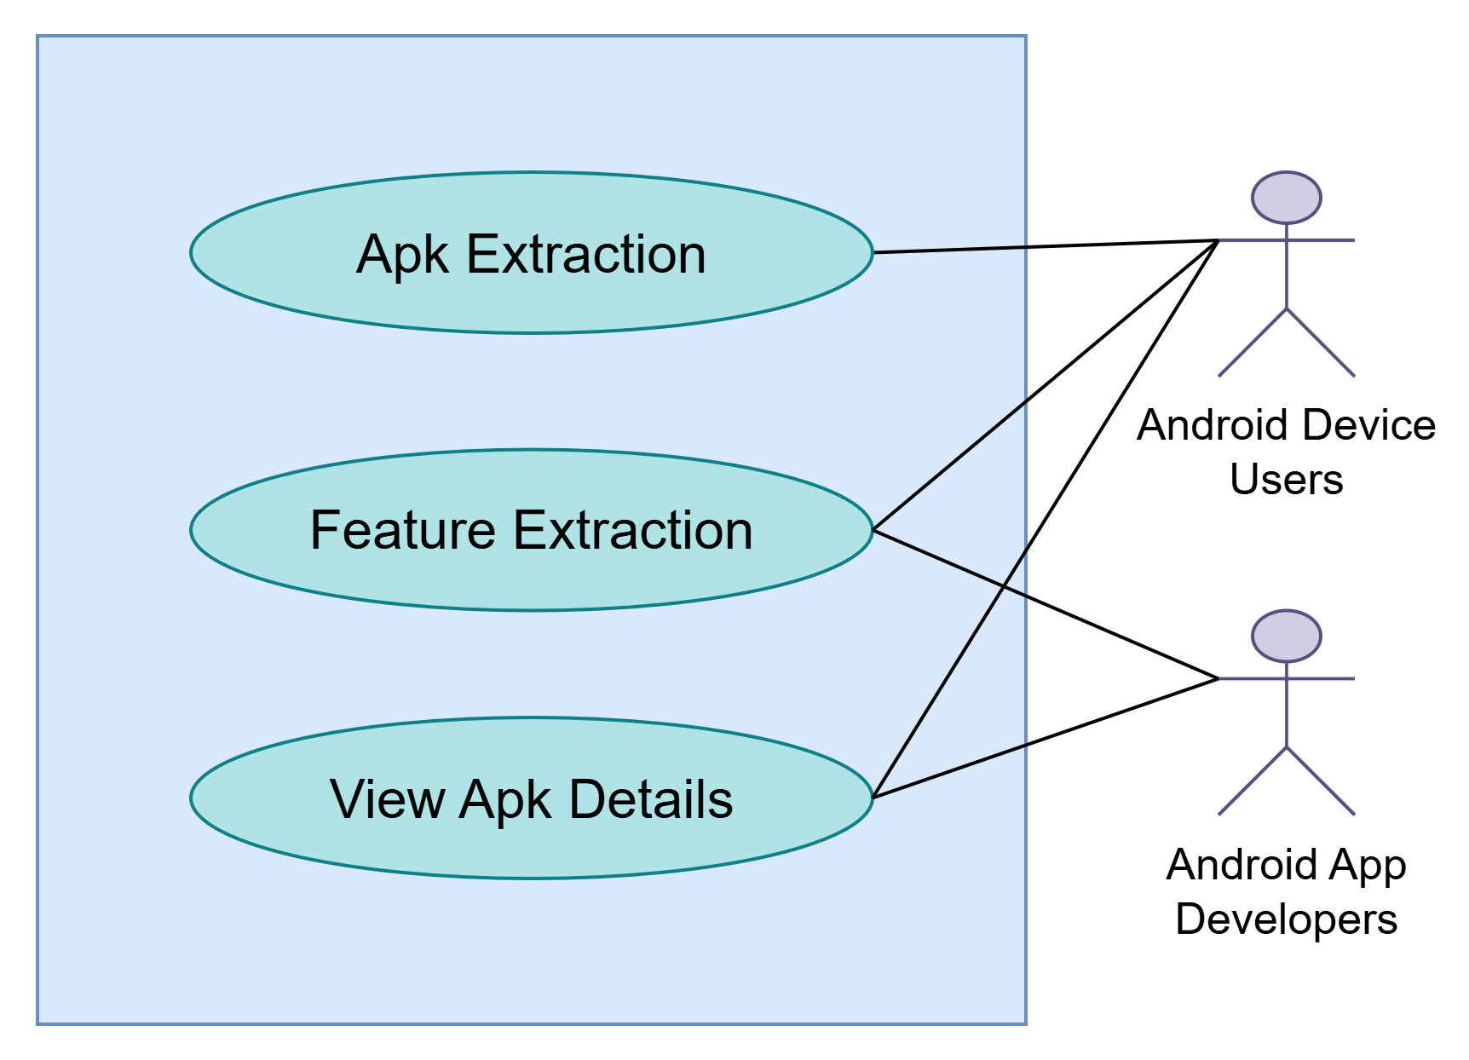

Figure 1.2.2: APK Analysis

## Level 1.3

**Name: Custom App Management**

Primary Actor: Android device users

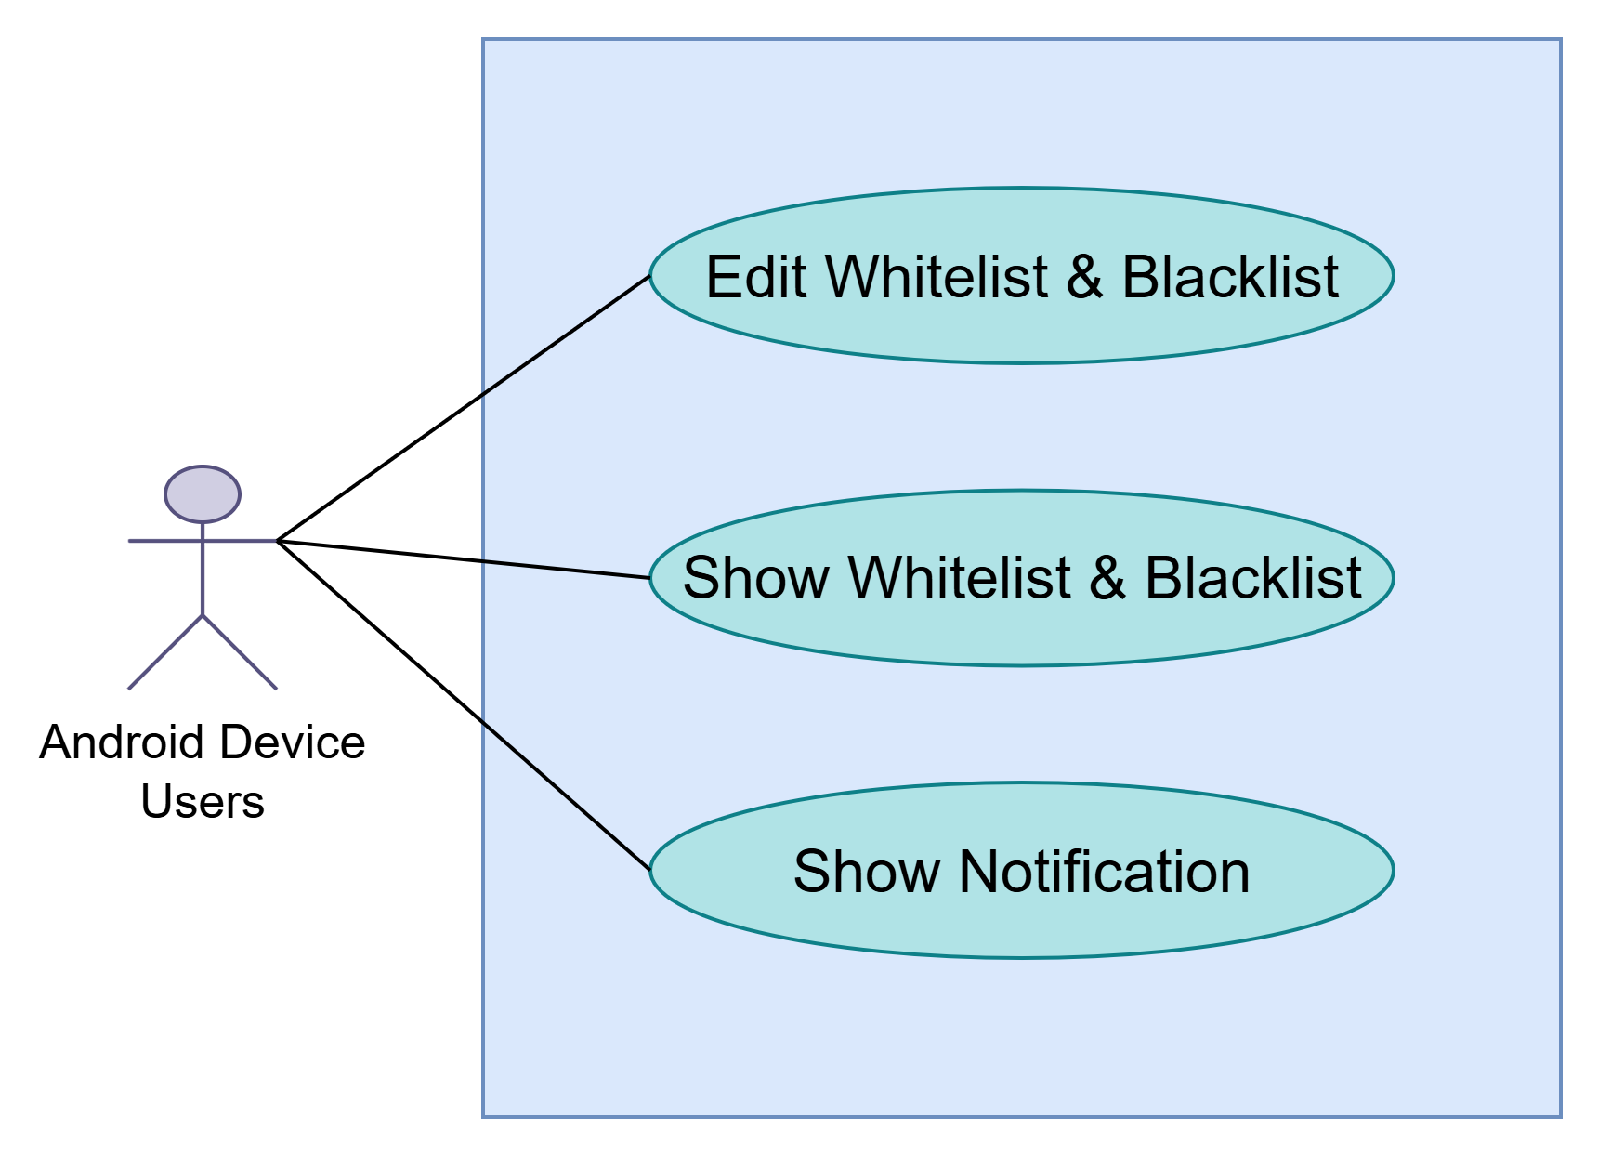

Figure 1.3: Custom App Management

## Level 1.4

**Name: Report Generation**

Secondary Actor: Android device users, Android app developers

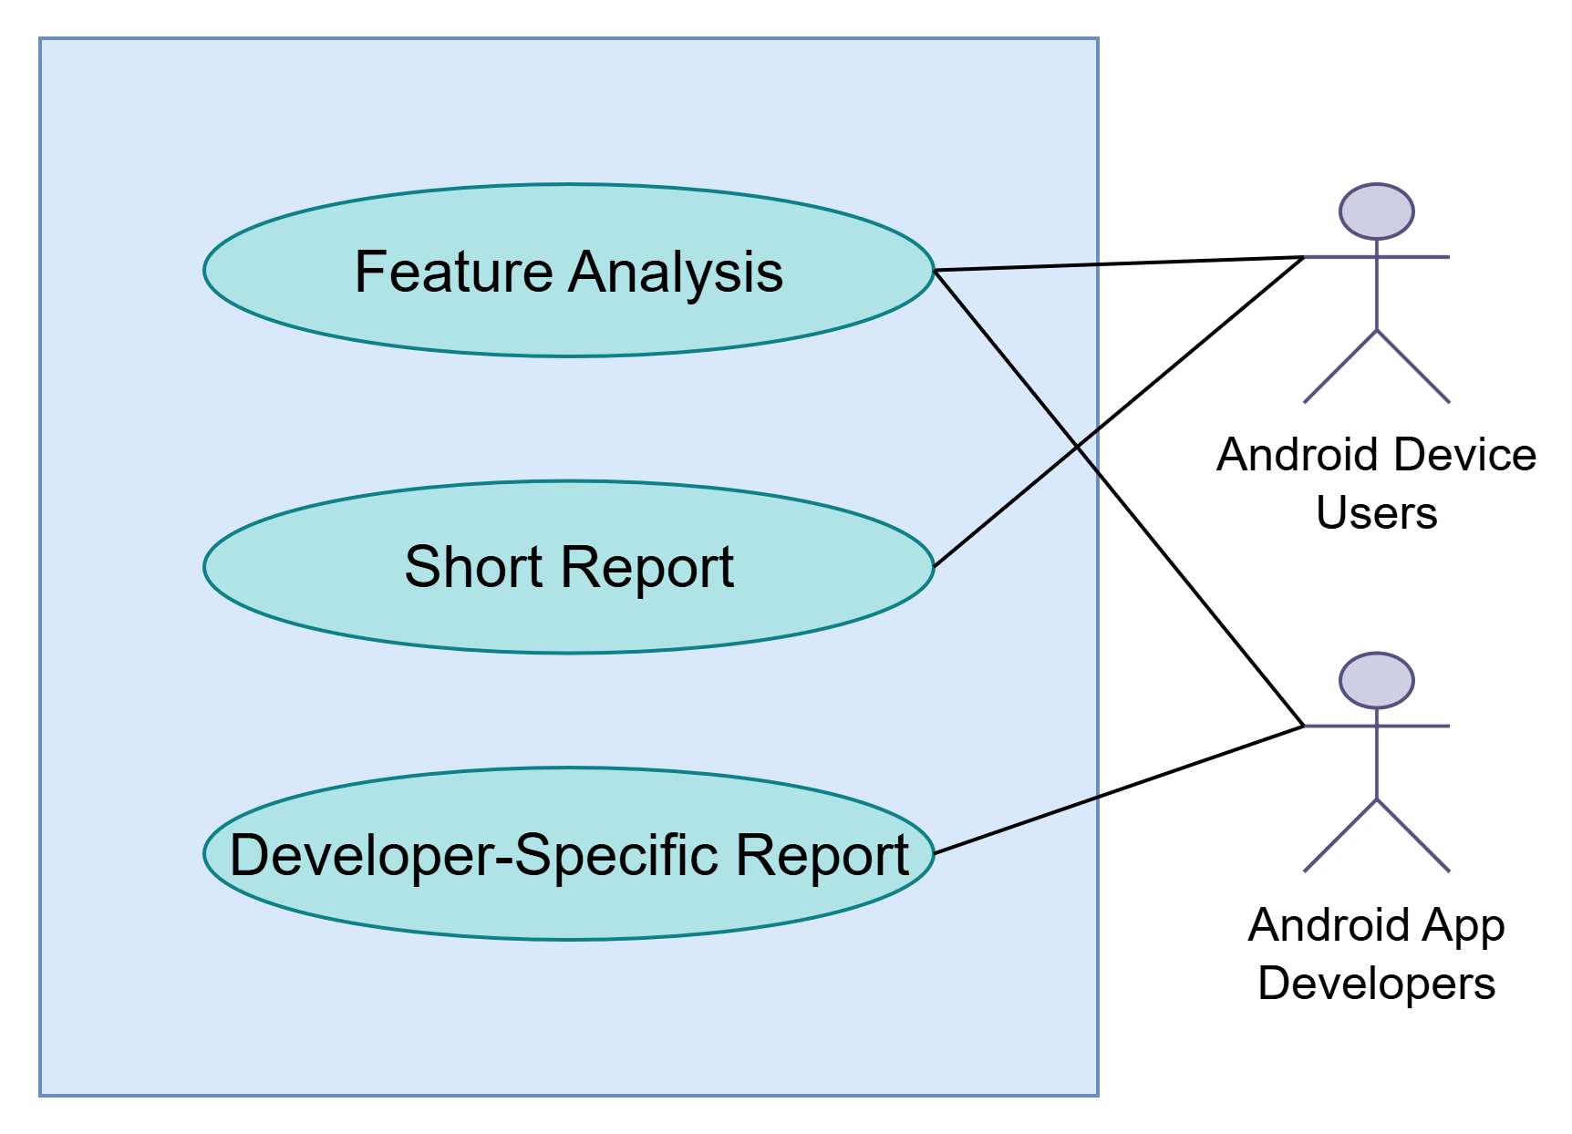

Figure 1.4: Report Generation

# 2.Swimlane Diagram

## 

## 

## 2.1. Definition of Swimlane Diagram

If software requirements include the necessity to create, extend or interact with a database or complex data structures need to be constructed and manipulated, then the software team chooses to create data models as part of overall requirements modeling. The entity-relationship diagram (ERD) defines all data objects that are processed within the system, the relationships between the data objects, and the information about how the data objects are entered, stored, transformed, and produced within the system.

## 

## 

## 2.2. Swimlane ID (SID) 1.1

**Name:** Authentication

Reference: Use Case Level 1.1

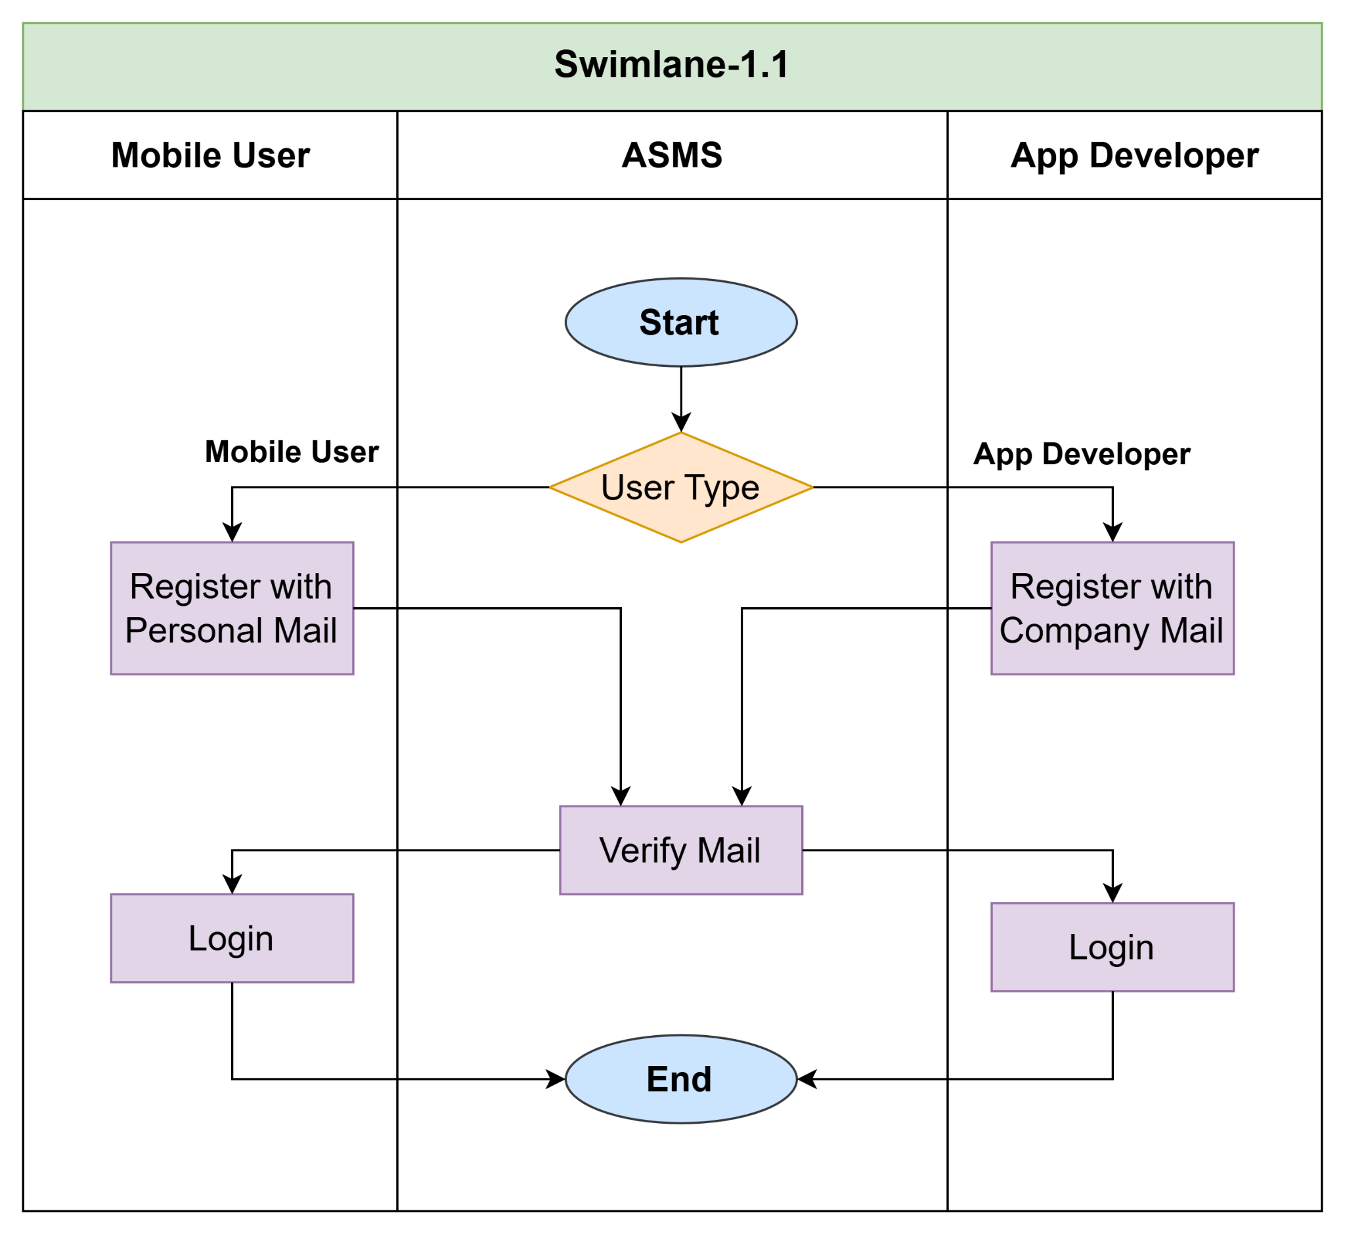

Figure: SID 1.1

## 2.3. Swimlane ID (SID) 1.2

**Name:** Malicious App Detection

Reference: Use Case Level 1.2

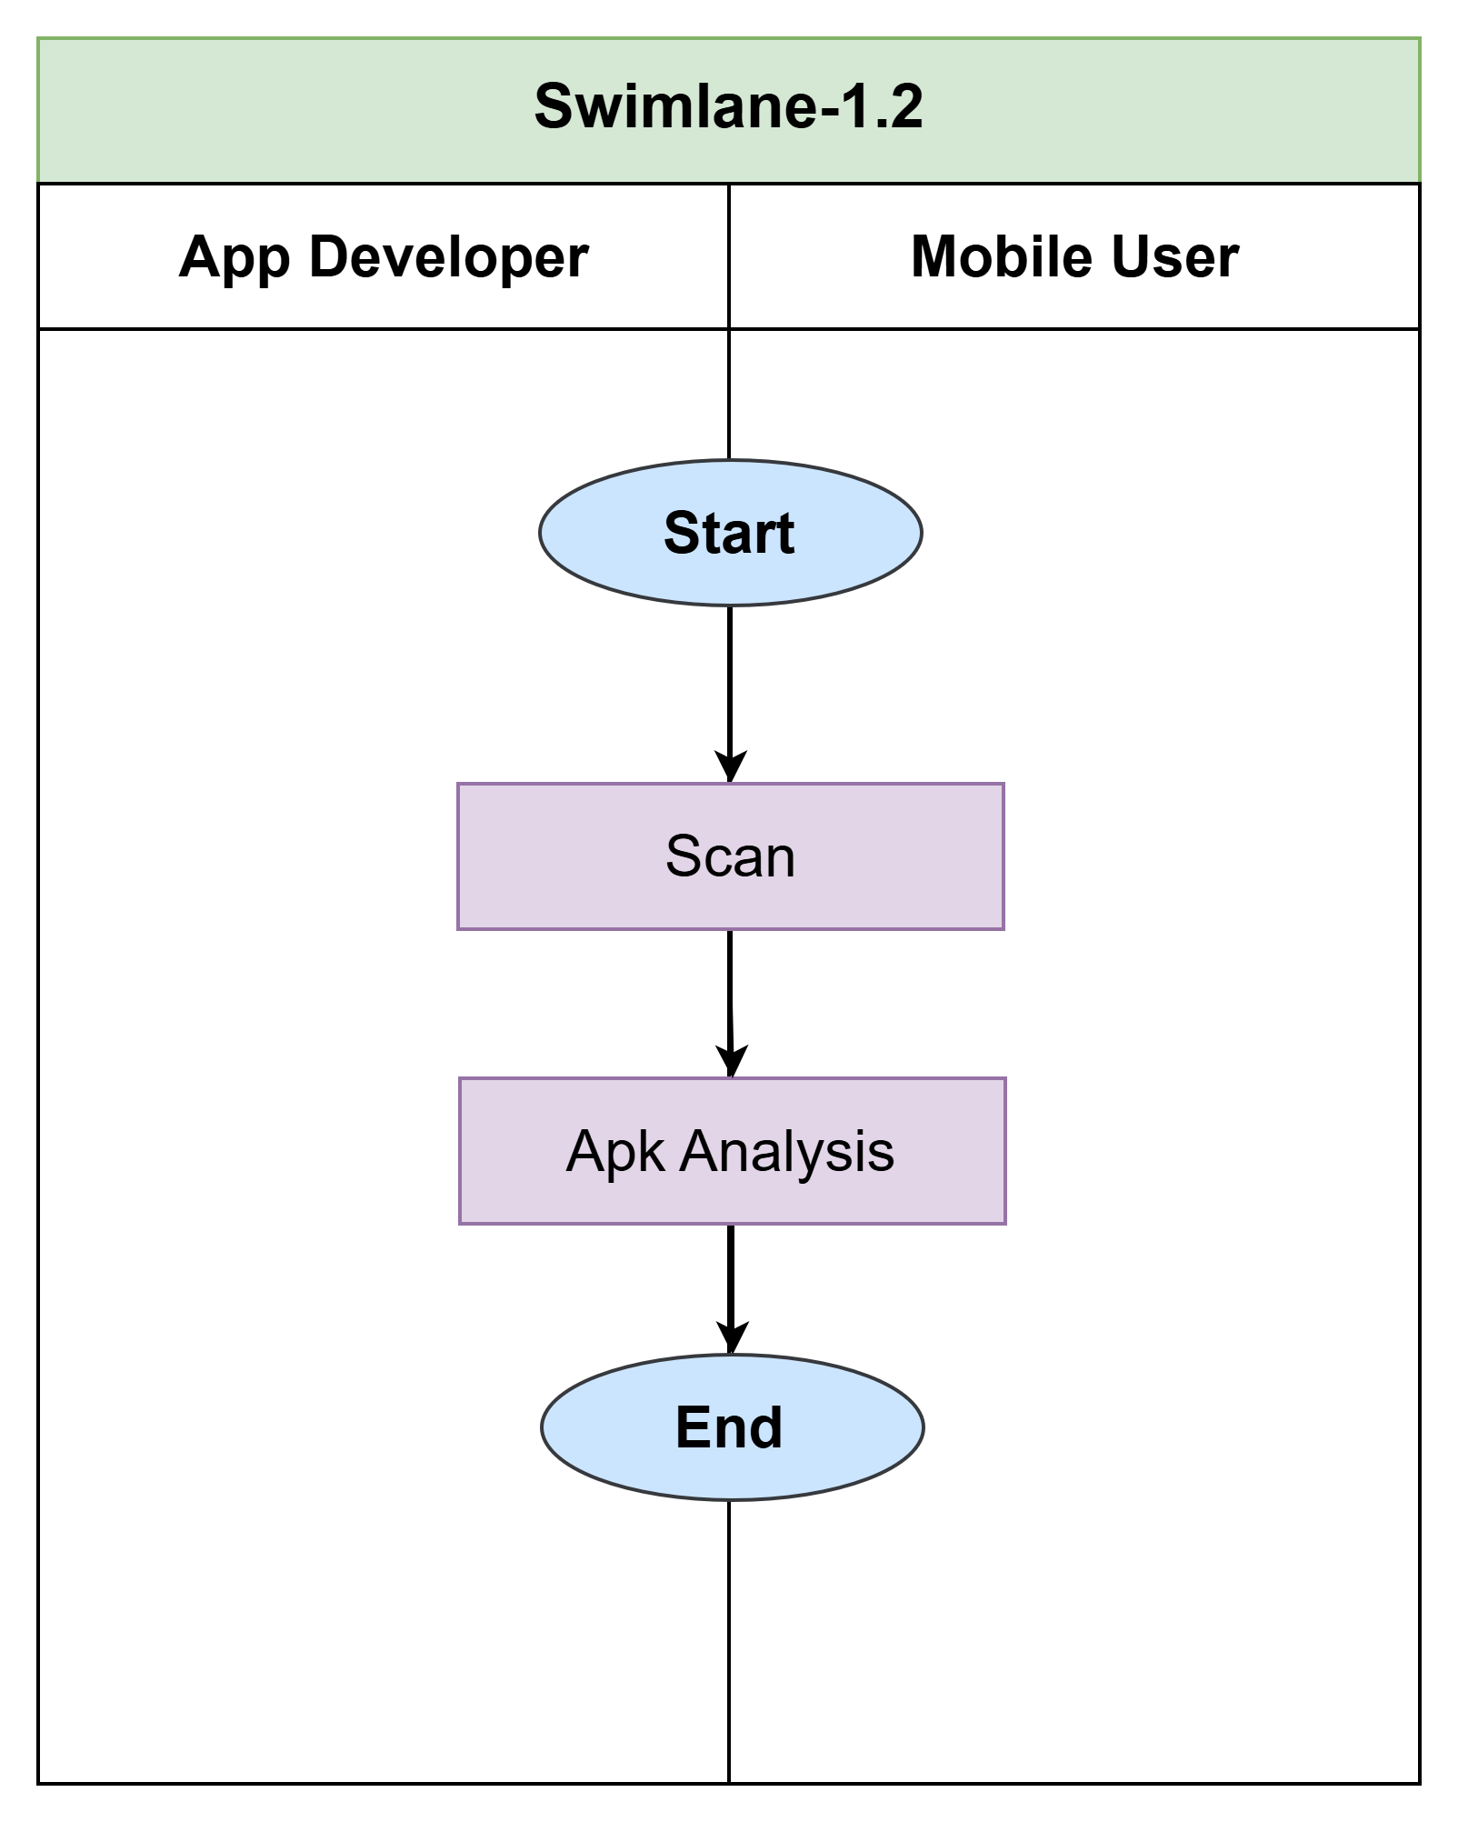

Figure: SID 1.2

## 2.3. Swimlane ID (SID) 1.2.1

**Name:** Scan

Reference: Use Case Level 1.2.1

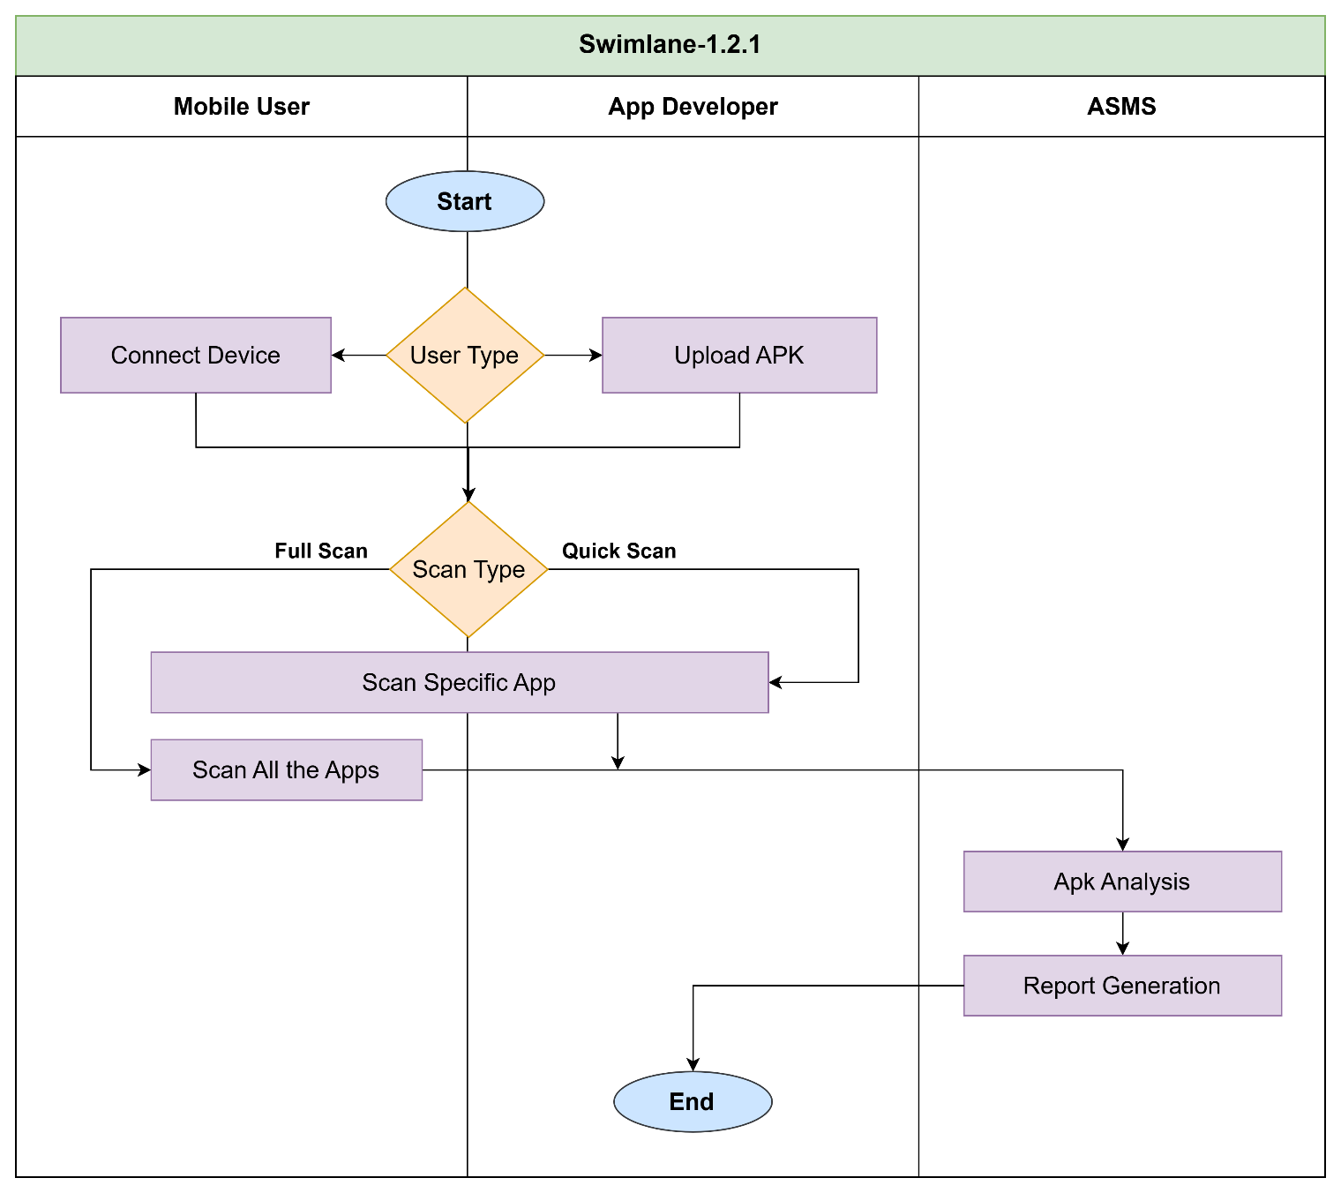

Figure: SID 1.2.1

## 2.4. Swimlane ID (SID) 1.2.2

**Name:** APK Analysis

Reference: Use Case Level 1.2.2

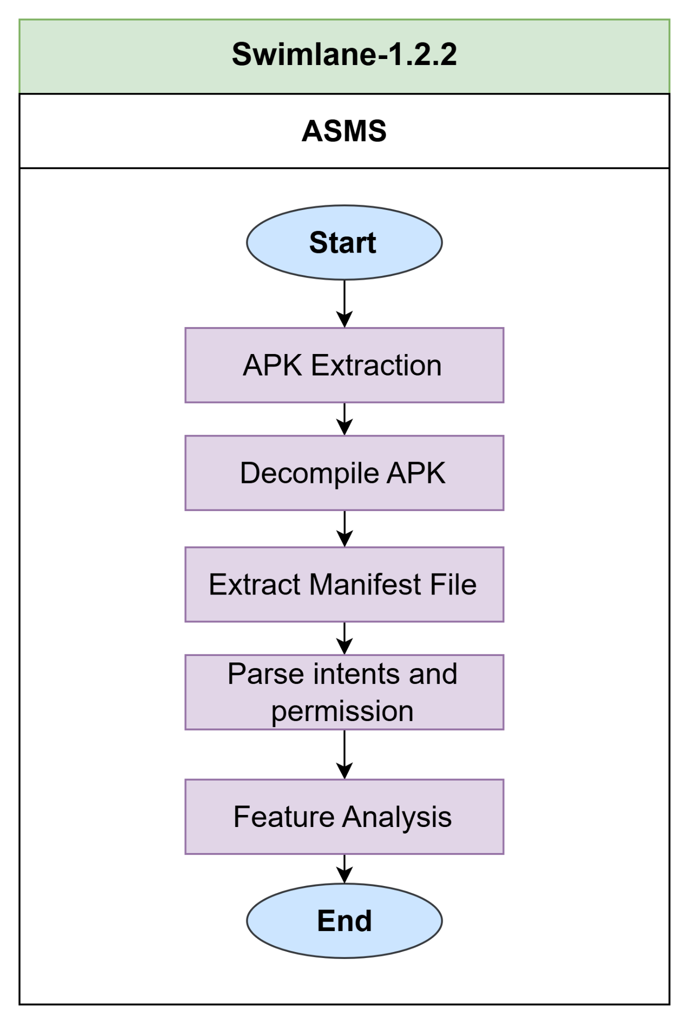

Figure: SID 1.2.2

## 2.5. Swimlane ID (SID) 1.3

**Swimlane-1.3:** Custom App Management

Reference: Use Case Level 1.3

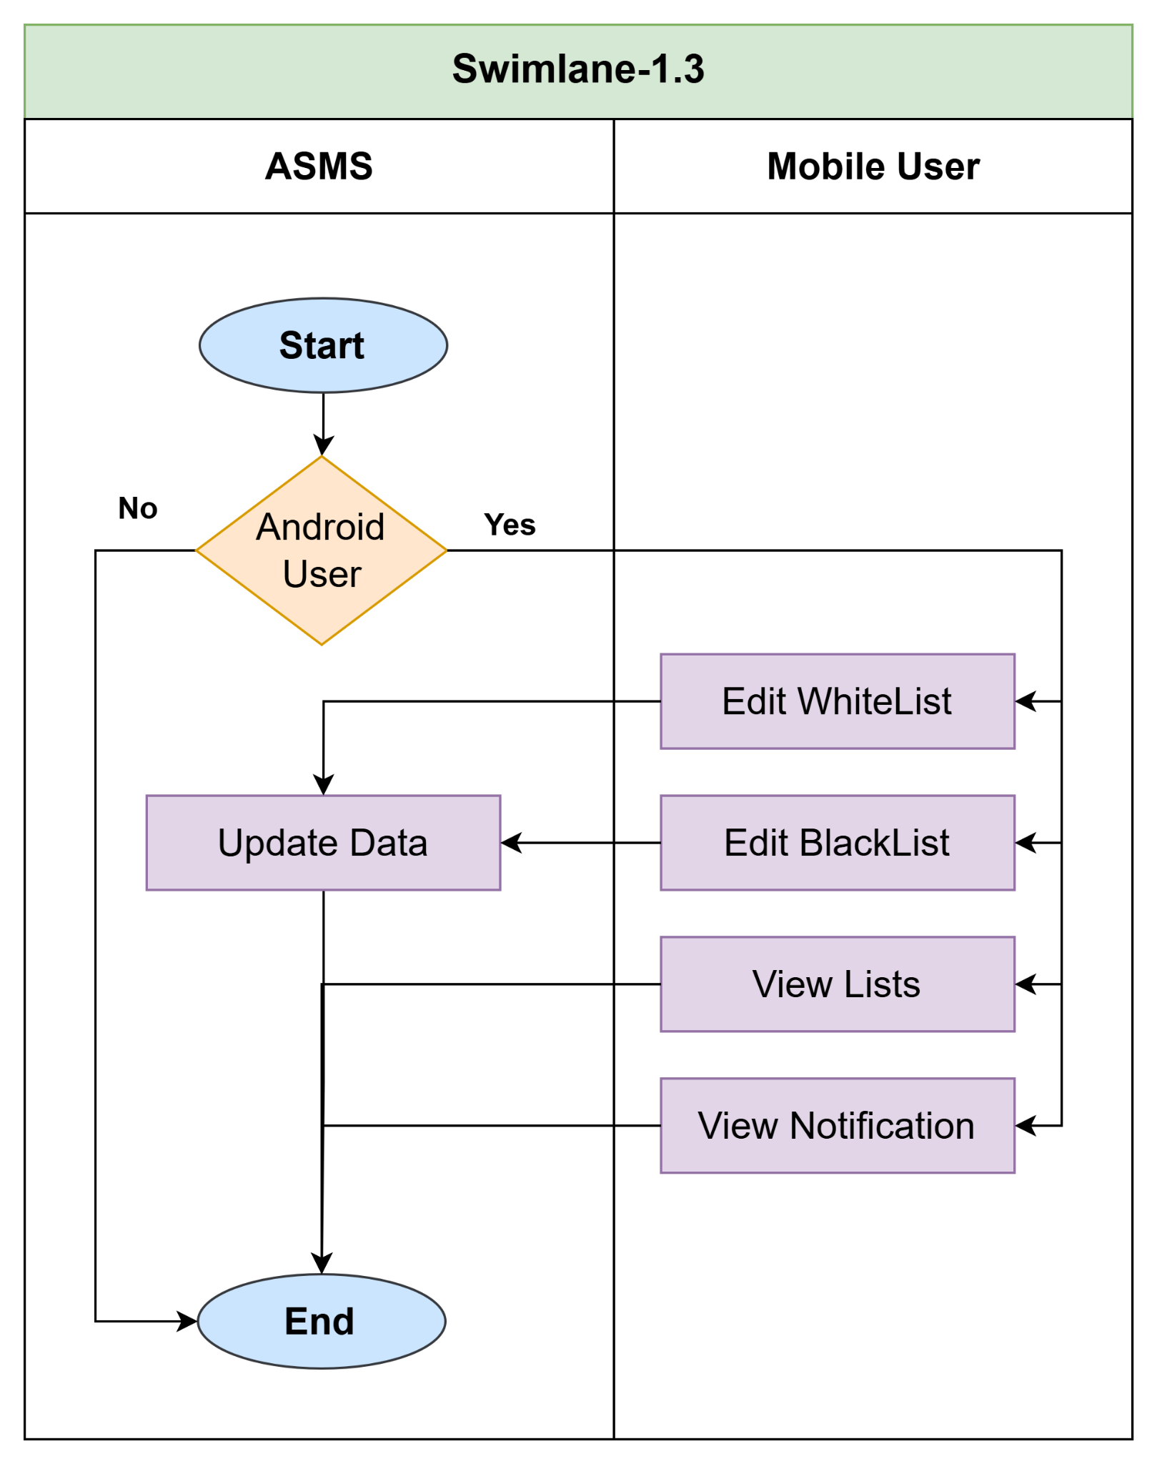

Figure: SID 1.3

## 2.6. Swimlane ID (SID) 1.4

**Name:** Report Generation

Reference: Use Case Level 1.4

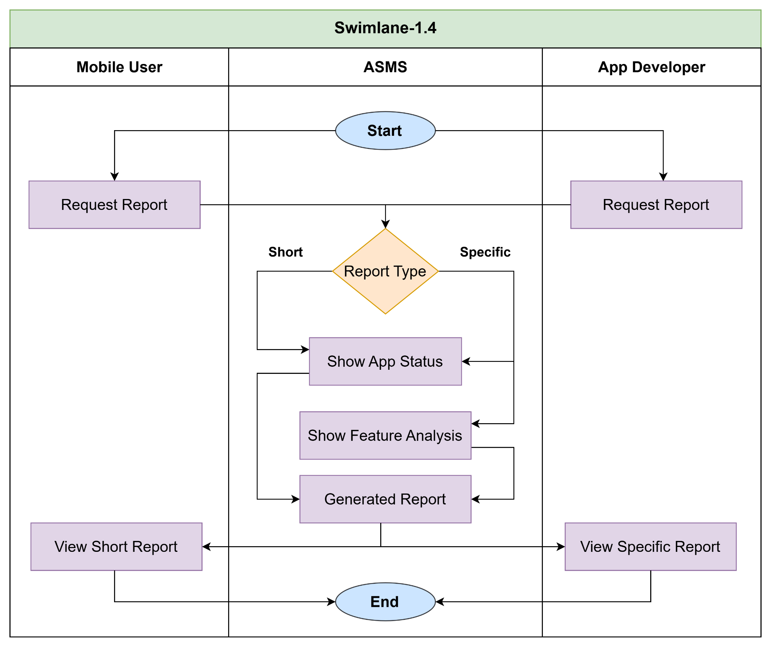

Figure: SID 1.4

# 3.Data Based Modeling

## 3.1. Definition of Database Diagram

Data modeling is a process used to define and analyze data requirements needed to support the business processes within the scope of corresponding information systems in organizations. Therefore, the process of data modeling involves professional data modelers working closely with business stakeholders, as well as potential users of the information system.

**Data Objects**

A data object is a representation of composite information that must be understood by the software.

## 3.2. Data Objects Identification:

|  |  |  |  |
| --- | --- | --- | --- |
| **SL** | **Noun** | **Problem/Solution Space** | **Attributes** |
| 1 | Droid Scanner | S |  |
| 2 | App | S | 64, 9, 35, 51, 59, 62 |
| 3 | Security | S |  |
| 4 | Management System | S |  |
| 5 | Software | S |  |
| 6 | Solution | S |  |
| 7 | Mobile Device | S |  |
| 8 | Threat | P |  |
| 9 | Name | S |  |
| 10 | App Development | S |  |
| 11 | User | S | 64, 9, 28, 57, 27 |
| 12 | Groups | S |  |
| 13 | Primary Mobile Device Users | S |  |
| 14 | Device Security | S |  |
| 15 | Mobile App Developers | S |  |
| 16 | Tools | S |  |
| 17 | Vulnerabilities | P |  |
| 18 | Privacy | S |  |
| 19 | Options | S |  |
| 20 | Full Scan | S |  |
| 21 | Quick Scan | S |  |
| 22 | Command | S |  |
| 23 | Forms | S |  |
| 24 | Security Monitoring | S |  |
| 25 | Tool | S |  |
| 26 | Setup | S |  |
| 27 | User Dashboard | S |  |
| 28 | Profile | S |  |
| 29 | Scans History | S |  |
| 30 | Blacklist | S |  |
| 31 | Whitelist | S |  |
| 32 | Applist | S |  |
| 33 | Malicious App Detection | S |  |
| 34 | Feature | S |  |
| 35 | APK Files | S |  |
| 36 | APK Extraction | S |  |
| 37 | Custom App Management | S |  |
| 38 | Notification | S | 64, 11, 76, 74, 62 |
| 39 | Risky Apps | S |  |
| 40 | Scan | S | 64, 74, 2, 50, |
| 41 | Outcome | S |  |
| 42 | User Database | S |  |
| 43 | Reports | S | 64, 40, 58, 51, 69, 59, 60, 61 |
| 44 | Scan Summaries | S |  |
| 45 | Data Privacy | P |  |
| 46 | Compliance | P |  |
| 47 | Safety | P |  |
| 48 | Launch | S |  |
| 49 | Dashboard | S | 64, 11, 28, 29, 30, 31 |
| 50 | Scan Reports | S |  |
| 51 | Permissions | S |  |
| 52 | Location | S |  |
| 53 | Camera | S |  |
| 54 | Permission Viewer | S |  |
| 55 | Request | S |  |
| 56 | Privacy | P |  |
| 57 | Role | S |  |
| 58 | App Details | S |  |
| 59 | Intents | S |  |
| 60 | Feature Analysis | S |  |
| 61 | API Calls | S |  |
| 62 | Status | S |  |
| 63 | Industry Standards | S |  |
| 64 | ID | S |  |
| 65 | Security Records | P |  |
| 66 | App History | P |  |
| 67 | Improvement | P |  |
| 68 | Platform | S |  |
| 69 | Security Status | S |  |
| 70 | Database | S |  |
| 71 | Integrity | S |  |
| 72 | Applications | S |  |
| 73 | Protection | P |  |
| 74 | Date | S |  |
| 75 | Result | S |  |
| 76 | Message | S |  |

## 3.3. Final Data Objects:

1. **User**
   * Attributes: User_ID, Name, Role (Primary User/Developer), Profile
2. **App**
   * Attributes: Package_Name, Name, APK_File, Permissions, Intent, Status (Malicious/Benign), API_Calls,
3. **Scan**
   * Attributes: Scan_ID, Type (Full/Quick), Date, App_ID (FK), User_ID (FK), Scan_Results
4. **Report**
   * Attributes: Report_ID, Scan_ID (FK), App Details, Permissions Used, Intent Analysis, Security Status
5. **Notification**
   * Attributes: Notification_ID, User_ID (FK), Message, Date, Status (Read/Unread)

## 3.4. Relationship between Objects:

| **Data Object** | **Relationship** | **Related Data Object** |
| --- | --- | --- |
| Scan | has | Report |
| User | performs | Scan |
| User | gets | Notification |
| User | has | App |
| App | analyzed through | Scan |
| Notification | gets | Report |

## 3.5. Entity Relation ( ER ) Diagram:

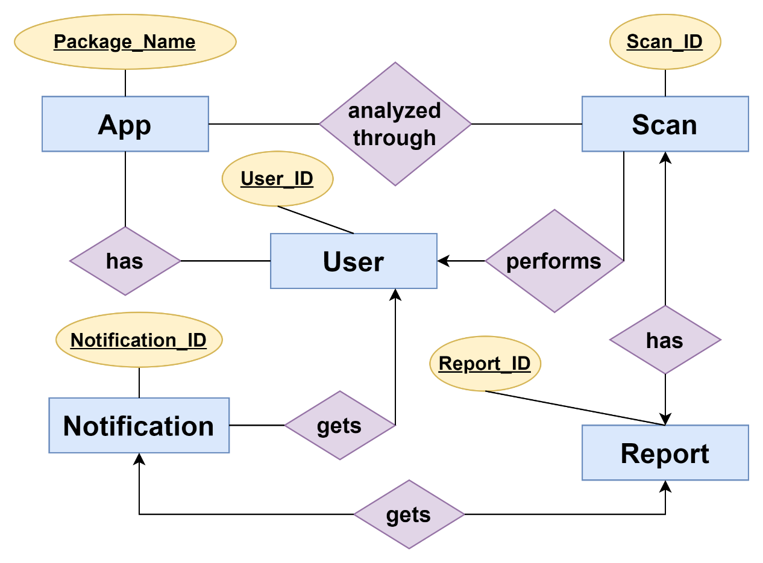

Figure 3: Entity Relation ( ER ) Diagram

## 3.6. Schema Diagram:

| **Data Object** | **Attribute** | **Type** | **Size** |
| --- | --- | --- | --- |
| User | User_ID  Name  Role  Profile | Varchar  Varchar  Varchar  Varchar | 100  100  50  100 |
| App | Package_Name  Name  Status  APK_File Permissions  Intent  API_Calls  Type | Varchar  Varchar  Varchar  Blob  Text  Text  Text  Text | 100  100  50 |
| Scan | Scan_ID  Type  App_ID (FK) User_ID (FK) Scan_Results  Date | Varchar  Varchar  Varchar  Varchar  Text  DateTime | 100  50  100  100 |
| Report | Report_ID  Scan_ID (FK)  Security Status  App Details Permissions Used Intent Analysis | Varchar Varchar  Varchar  Varchar  Varchar  Varchar | 100  100  50  100  100  100 |
| Notification | Notification_ID  User_ID (FK) Message  Date  Status | Varchar Varchar  Varchar  DateTime  Varchar | 100  100  100  100 |

# 4.CLASS-BASED MODELING

## 4.1. CLASS BASED MODELING CONCEPT:

Class-based modelling represents the objects that the system will manipulate, the operations that will be applied to the objects, relationships between the objects and the collaborations that occur between the classes that are defined.

## 4.2. General Classification:

Candidate classes were then characterized in seven general classes. The seven general characteristics are as follows:

1. External entities

2. Things

3. Events

4. Roles

5. Organizational units

6. Places

7. Structures

## 4.3. Noun List:

| **SL** | **Noun** | **General Classification** |
| --- | --- | --- |
| 1 | Droid Scanner | 2 |
| 2 | App | 1, 2, 7 |
| 3 | Security | 2, 3 |
| 4 | Management System | 2, 7 |
| 5 | Software | 2, 7 |
| 6 | Solution | 2, 7 |
| 7 | Mobile Device | 2, 6 |
| 8 | Threat | 2, 3 |
| 9 | Standards | 2, 7 |
| 10 | App Development | 2, 3 |
| 11 | Stakeholder | 1, 4 |
| 12 | Groups | 5 |
| 13 | Android Device User | 1, 4, 5 |
| 14 | Device Security | 2 |
| 15 | Android App Developers | 1, 4, 5 |
| 16 | Tools | 2, 7 |
| 17 | Vulnerabilities | 2, 3 |
| 18 | Privacy | 2 |
| 19 | Options | 2 |
| 20 | Full Scan | 2, 3 |
| 21 | Quick Scan | 2, 3 |
| 22 | Command | 2, 3 |
| 23 | Forms | 2, 7 |
| 24 | Security Monitoring | 2, 3 |
| 25 | Tool | 2, 7 |
| 26 | Setup | 2, 7 |
| 27 | User | 1, 2, 3, 7 |
| 28 | Profile | 2 |
| 29 | Scans History | 2 |
| 30 | Blacklist | 2 |
| 31 | Whitelist | 2 |
| 32 | Applist | 2, 3 |
| 33 | Malicious App Detection | 2 |
| 34 | Feature | 2, 3 |
| 35 | APK Files | 2 |
| 36 | APK Extraction | 2, 7 |
| 37 | Custom App Management | 2, 7 |
| 38 | Checks | 2, 3 |
| 39 | Risky Apps | 2 |
| 40 | Scan | 2, 3, 7 |
| 41 | Outcome | 2, 7 |
| 42 | User Database | 2, 7 |
| 43 | Reports | 2, 3, 7 |
| 44 | Scan Summaries | 2 |
| 45 | Data Privacy | 2 |
| 46 | Compliance | 2 |
| 47 | Safety | 2, 3 |
| 48 | Launch | 2 |
| 49 | Dashboard | 1, 2, 7 |
| 50 | Scan Reports | 2, 7 |
| 51 | Permissions | 6, 7 |
| 52 | Location | 6, 7 |
| 53 | Camera | 2, 7 |
| 54 | Permission Viewer | 2 |
| 55 | Request | 2 |
| 56 | Privacy | 2 |
| 57 | Report | 2, 7 |
| 58 | App Details | 2, 3 |
| 59 | Intents | 2 |
| 60 | Feature Analysis | 2 |
| 61 | API Calls | 2 |
| 62 | Status | 2 |
| 63 | Industry Standards | 2 |
| 64 | Issue | 2 |
| 65 | Security Records | 2 |
| 66 | Traceable History | 2, 7 |
| 67 | Improvement | 2, 7 |
| 68 | ML Model | 1, 2, 3 |
| 69 | Notification | 2, 3, 7 |
| 70 | Database | 2, 3, 7 |
| 71 | Integrity | 2, 3 |
| 72 | Applications | 3 |
| 73 | Protection | 6, 7 |

## 4.4. Verb List:

|  |  |  |  |
| --- | --- | --- | --- |
| **SL** | **Verb** | **SL** | **Verb** |
|  | designed |  | stay |
|  | safeguarding |  | ensure |
|  | ensuring |  | serves |
|  | serves |  | evaluate |
|  | prioritize |  | improve |
|  | need |  | access |
|  | ensure |  | enables |
|  | comply |  | view |
|  | provides |  | let |
|  | offering |  | save |
|  | scan |  | review |
|  | ensure |  | making |
|  | operates |  | shows |
|  | initiate |  | choose |
|  | accessing |  | keep |
|  | displays |  | remove |
|  | performs |  | generates |
|  | identify |  | detailing |
|  | analyzing |  | align |
|  | allows |  | detect |
|  | save |  | stored |
|  | examine |  | ensuring |
|  | whitelist |  | maintain |
|  | avoid |  | release |
|  | blacklist |  | prioritize |
|  | store |  | receive |
|  | enables |  | Empower |
|  | helping |  |  |

For all lists of Noun general classification is performed. If a noun is an essential entity or fill-up 3 or more classification criteria then it is considered as a potential class. Here potential classes are:

1. User
2. Authentication
3. Android Device User
4. Android App Developer
5. Scan
6. Report
7. ML Model
8. Notification
9. Dashboard
10. App
11. Database

## 4.5. Selection Criteria:

1. Retain information

2. Needed services

3. Multiple attributes

4. Common attributes

5. Common operations

6. Essential requirements

|  |  |
| --- | --- |
| **Potential Class** | **Selection Criteria** |
| User | 1, 2, 3, 4, 5 (selected) |
| Android Device User | 2, 5, 6 (selected) |
| Android App Developer | 2, 5, 6 (selected) |
| Scan | 1, 2, 3, 4, 5 (selected) |
| Report | 1, 2, 3, 4, 5 (selected) |
| ML Model | 1, 2, 3, 6 (selected) |
| Notification | 1, 2, 3, 4, 5 (selected) |
| Dashboard | 2, 3, 5, 6 (selected) |
| App | 1, 2, 3, 4, 5 (selected) |
| Database | 1, 2, 3, 4, 5 (selected) |

## 4.6. Analysis:

Here the list of Final Potential Classes that fulfills Selection Criteria:

1. Authentication
2. User
3. Android Device User
4. Android App Developer
5. App
6. Scan
7. Report
8. ML Model
9. Notification
10. Dashboard
11. Database

## 4.7. Class Cards

After identifying our final classes we have generated the following class cards.

|  |  |
| --- | --- |
| **Authentication** | |
| **Attributes** | **Methods** |
| Email_ID | createAccount() |
| User_ID | login() |
| Password | logout() |
|  | forgetPassword() |
| **Responsibilities** | **Collaborators** |
| Authentication of users | Mail System, User |

|  |  |
| --- | --- |
| **User** | |
| **Attributes** | **Methods** |
| User_ID | viewProfile() |
| Name | updateProfile() |
| Password |  |
| Role |  |
| **Responsibilities** | **Collaborators** |
| Manage user accounts and profiles. | Dashboard |

|  |  |
| --- | --- |
| **Android Device User** | |
| **Attributes** | **Methods** |
| User_ID | viewScanHistory() |
| Blacklist | addToBlacklist() |
| Whitelist | addToWhitelist() |
|  | connectDevice() |
| **Responsibilities** | **Collaborators** |
| Manage blacklist and whitelist for apps on connected devices. | App, Dashboard |
| Connect devices. | Scan |

|  |  |
| --- | --- |
| **Android App Developer** | |
| **Attributes** | **Methods** |
| Developer_ID | viewScanReport() |
| Uploaded_Apps | uploadAPK() |
|  | viewUploadedApps() |
| **Responsibilities** | **Collaborators** |
| Upload and review APK files for security scanning. | App,Scan |
| Access reports to ensure compliance with standards. | Dashboard |

|  |  |
| --- | --- |
| **App** | |
| **Attributes** | **Methods** |
| PackageName | checkSecurityStatus() |
| APK_File | extractAPKDetails() |
| Version | extractfeatures() |
| Permissions | updateStatus() |
| Intents |  |
| Status |  |
| **Responsibilities** | **Collaborators** |
| Security check and status update | ML Model |
| Analyze permissions and intents to meet compliance standards. | ML Model |

|  |  |
| --- | --- |
| **Scan** | |
| **Attributes** | **Methods** |
| Scan_ID | performQuickScan() |
| Type | performFullScan() |
| Date | uploadScanResults() |
| APK_ID | analyzeApp() |
| Report_ID |  |
| **Responsibilities** | **Collaborators** |
| Analyze apps and generate detailed reports. | App, Report |

|  |  |
| --- | --- |
| **Report** | |
| **Attributes** | **Methods** |
| Report_ID | generateScanReport() |
| Scan_ID | storeScanDetails() |
| App_ID |  |
| App Details |  |
| **Responsibilities** | **Collaborators** |
| Provide Scan Details | Scan |
| Detail app permissions and intents. | App |
| Provide Scan Report | Dashboard |

|  |  |
| --- | --- |
| **ML Model** | |
| **Attributes** | **Methods** |
| Model_ID | trainModel() |
| Classifier | classifyApp() |
| Trained_Data | improveDatabase() |
| Results |  |
| **Responsibilities** | **Collaborators** |
| Analyze extracted APK data and classify apps as malicious or benign. | Scan, App |
| Continuously improve the model using new data. | Database |

|  |  |
| --- | --- |
| **Notification** | |
| **Attributes** | **Methods** |
| Notification_ID | sendNotification() |
| User_ID (FK) | notifyScanResults() |
| Message | viewNotifications() |
| **Responsibilities** | **Collaborators** |
| Notify users of scan results and detected vulnerabilities. | User, Dashboard |

|  |  |
| --- | --- |
| **Dashboard** | |
| **Attributes** | **Methods** |
| Dashboard_ID | viewUserDashboard() |
| Scan_History | updateScanHistory() |
| Connected_Devices | manageConnectedDevices() |
| **Responsibilities** | **Collaborators** |
| Display and update scan history | Report |
| Show and manage connected devices | User |

|  |  |
| --- | --- |
| **Database** | |
| **Attributes** | **Methods** |
| Report_ID | storeScanReport() |
| Scan_ID | storeScanDetails() |
| Permissions | updateDatabase() |
| **Responsibilities** | **Collaborators** |
| Store detailed app permissions and intents. | App |

## 4.7. CRC Diagram:

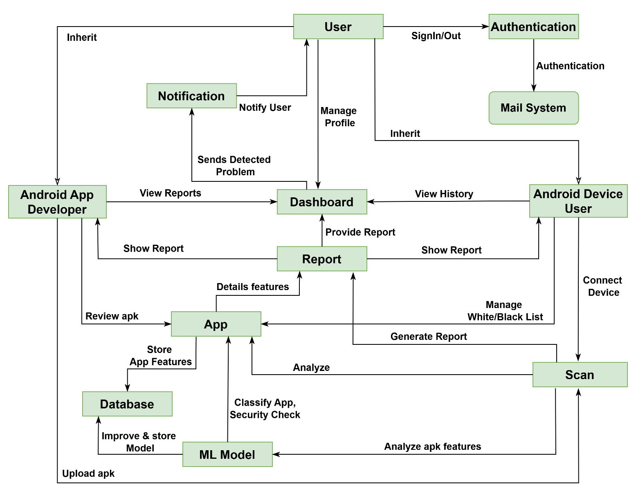

Figure 4: CRC Diagram

# 5.Behavioral Modeling

## 5.1. Definition of Behavioral Modeling:

The behavioral model indicates how software will respond to external events or stimuli. In the context of behavioral modeling, two different characterizations of states must be considered: (1) the state of each class as the system performs its function and (2) the state of the system as observed from the outside as the system performs its function.

**State Transition Diagram**

One component of a behavioral model is a UML state diagram that represents active states for each class and the events (triggers) that cause changes between these active states.

## 5.2. Lists of events:

| **Sl** | **Event** | **Initiator** | **Collaborator** |
| --- | --- | --- | --- |
|  | Account Creation | Authentication | User |
|  | Profile Update | User | Dashboard |
|  | Authentication | Authentication | Mail System |
|  | Scan History View | Android Device User | Dashboard |
|  | Update Blacklist | Android Device User |  |
|  | Update Whitelist | Android Device User |  |
|  | Connect Device | Android Device User |  |
|  | View Scan Report | User | Dashboard |
|  | APK Upload | Android App developers | Scan |
|  | Quick Scan | User | Scan |
|  | Full Scan | User | Scan |
|  | App Analysis | Scan | App |
|  | Scan Report Generation | Report | App,ML Model |
|  | Store Scan Details | Report | Scan |
|  | Train Model | ML Model |  |
|  | Classify App | ML model | App |
|  | Send Notification | Notification | Dashboard |
|  | Notify Scan Results | Notification | Dashboard |
|  | View Notifications | User | Notification |
|  | View User Dashboard | User | Dashboard |
|  | Extract APK Details | Scan | App |
|  | Status Update | App | ML Model |
|  | Store Scan Report | Report | Database |

## 5.3 State Transition Diagram

### 5.3.1. ID: 1

**Name: Authentication**

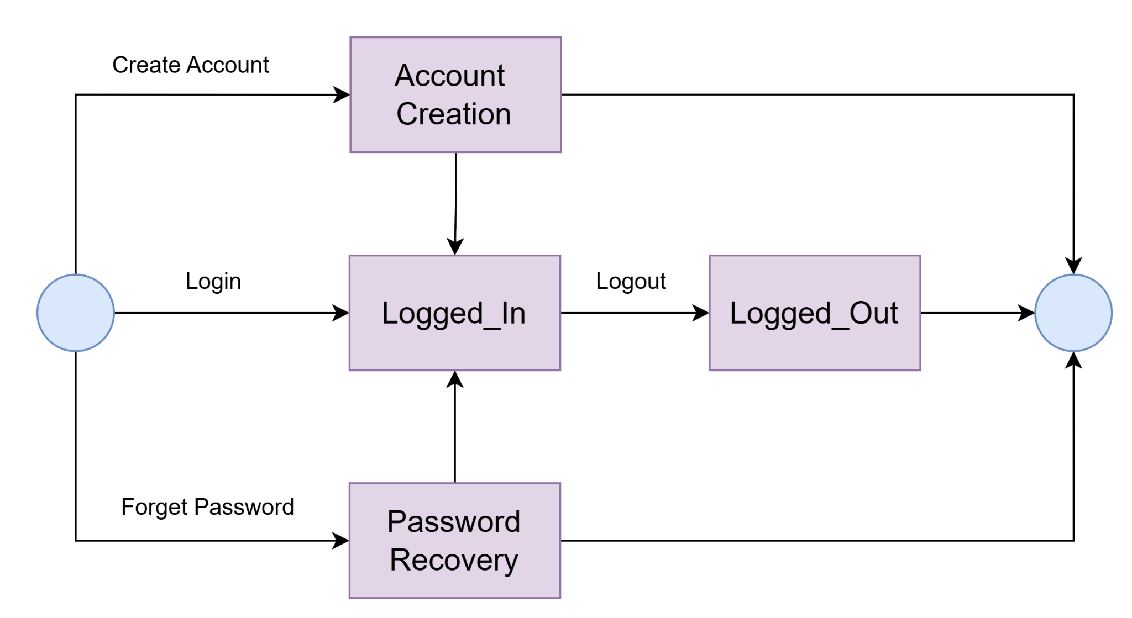

Figure 5.1: Authentication:

### 5.3.2. ID: 2

**Name: Android Device User**

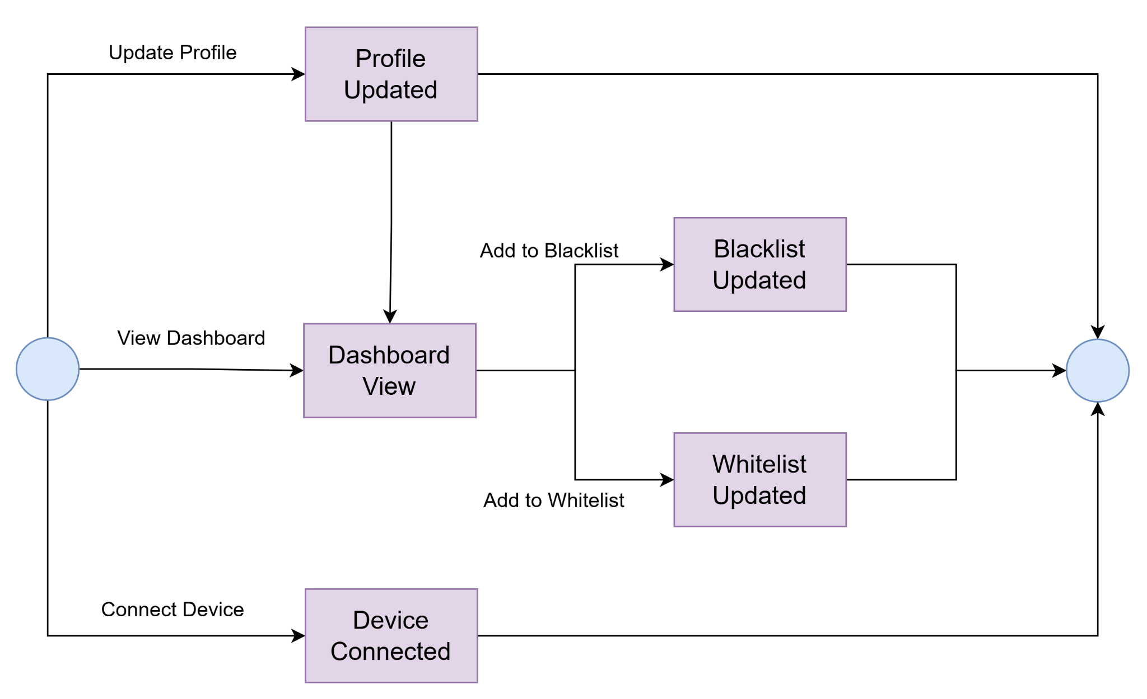

Figure 5.2: Android Device User

### 

### 5.3.3. ID: 3

**Name: Android App Developer**

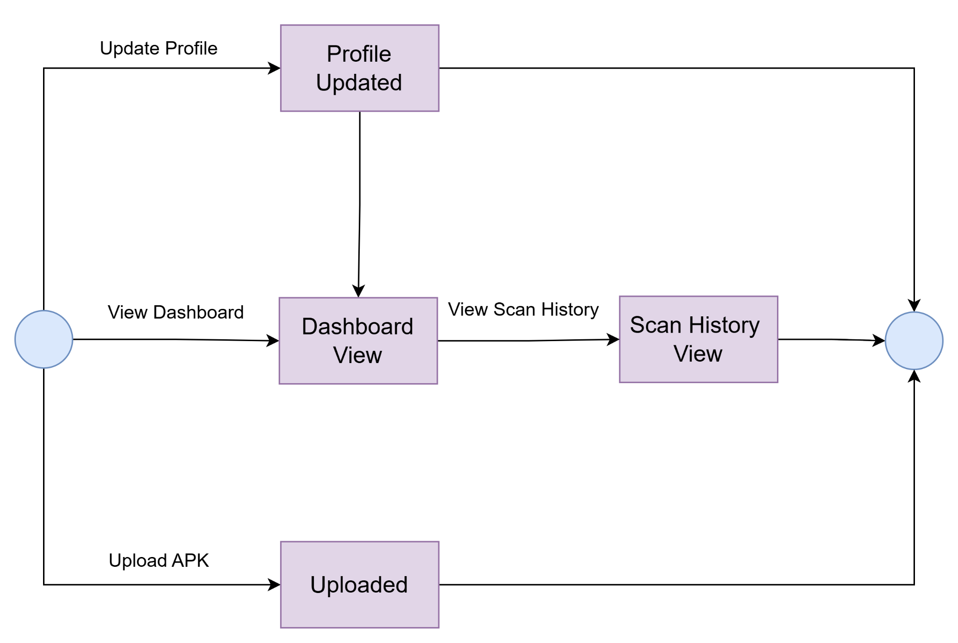

Figure 5.3: Android App Developer

### 5.3.4. ID: 4

**Name: App**

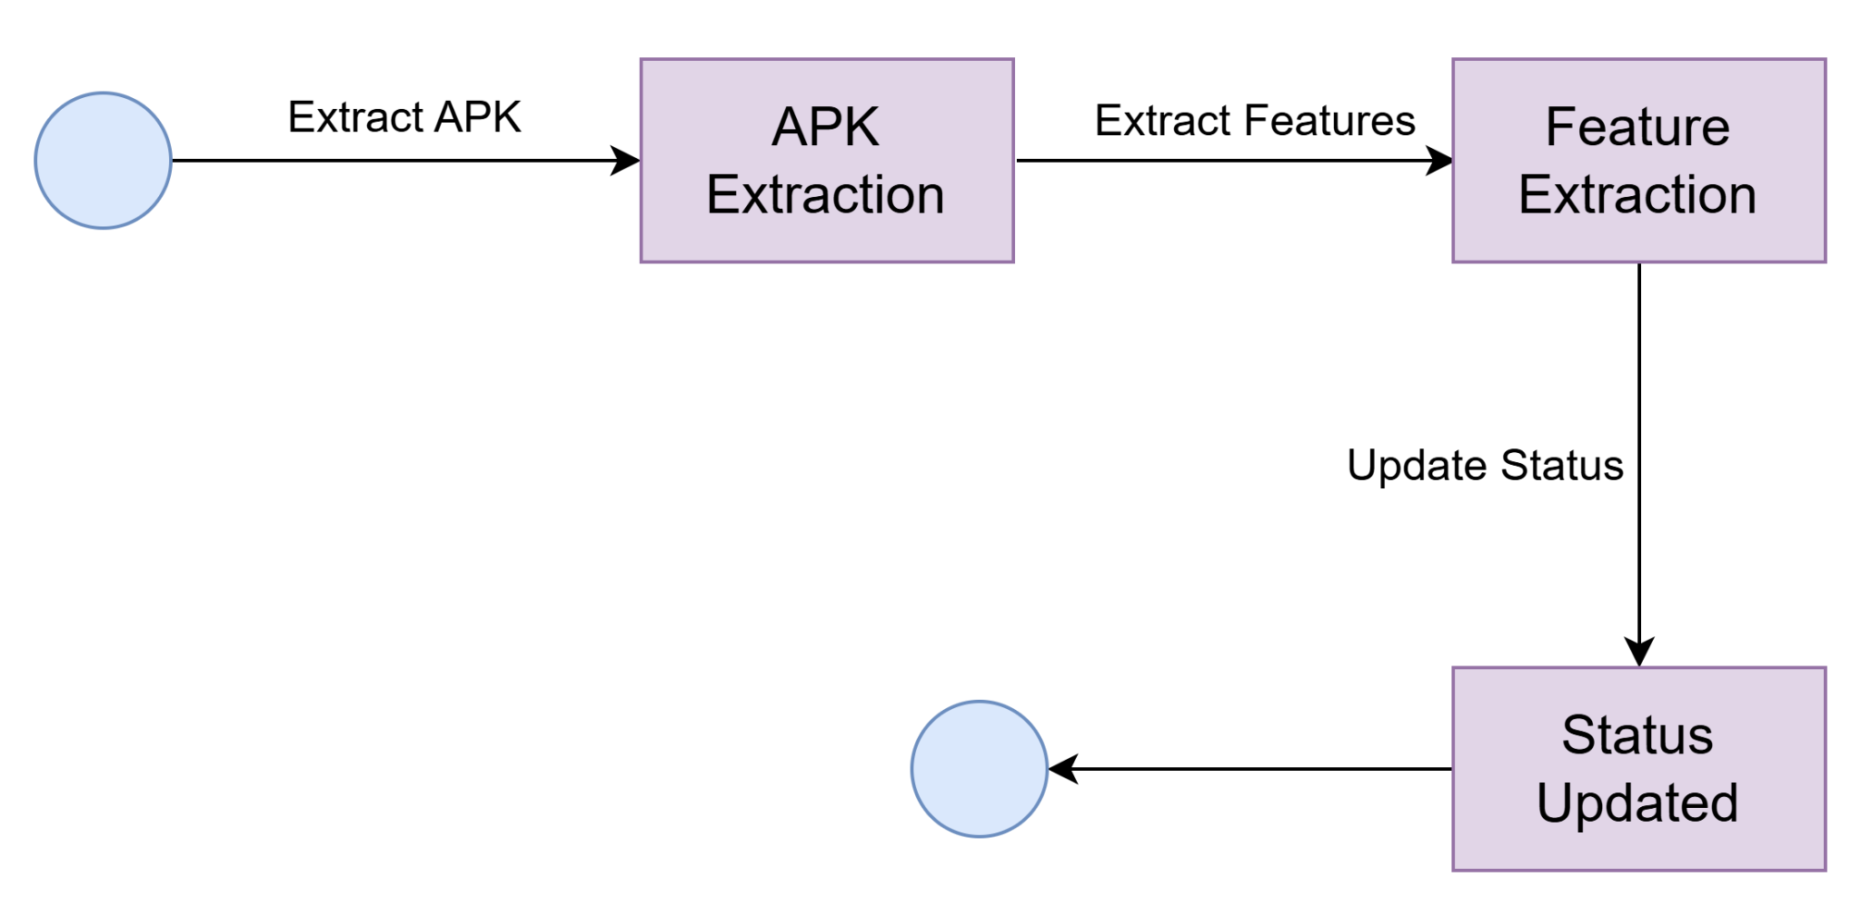

Figure 5.4: App

### 5.3.5. ID: 5

**Name: Scan**

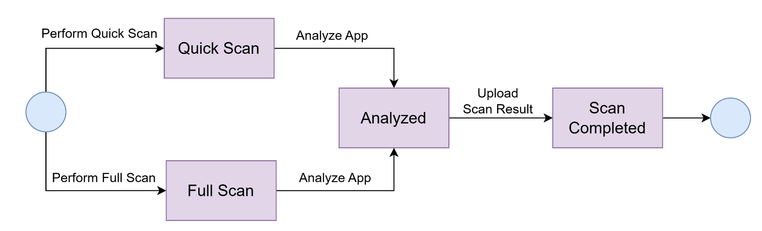

Figure 5.5: Scan

### 5.3.6. ID: 6

**Name: Report**

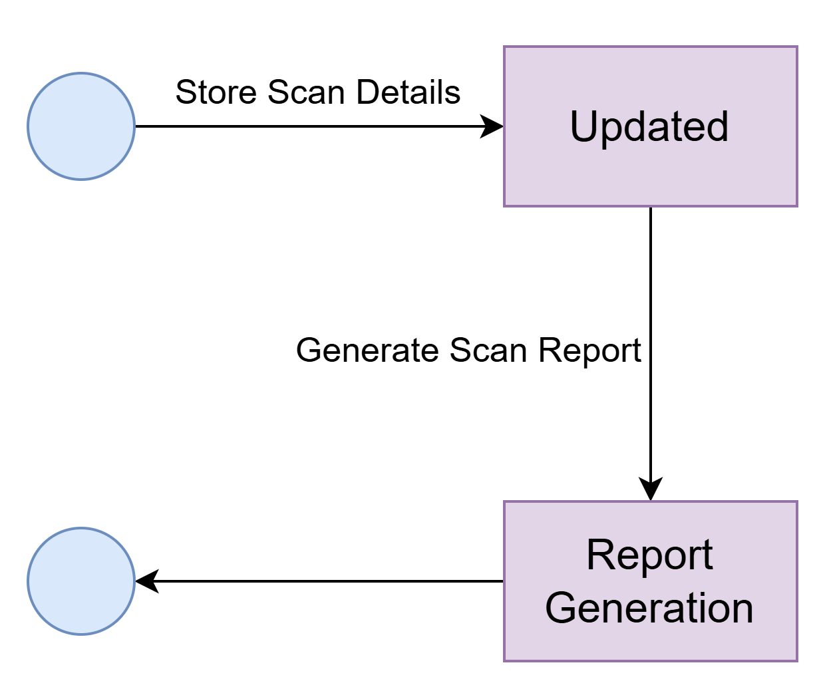

Figure 5.6: Report

### 5.3.7. ID: 7

**Name: ML Model**

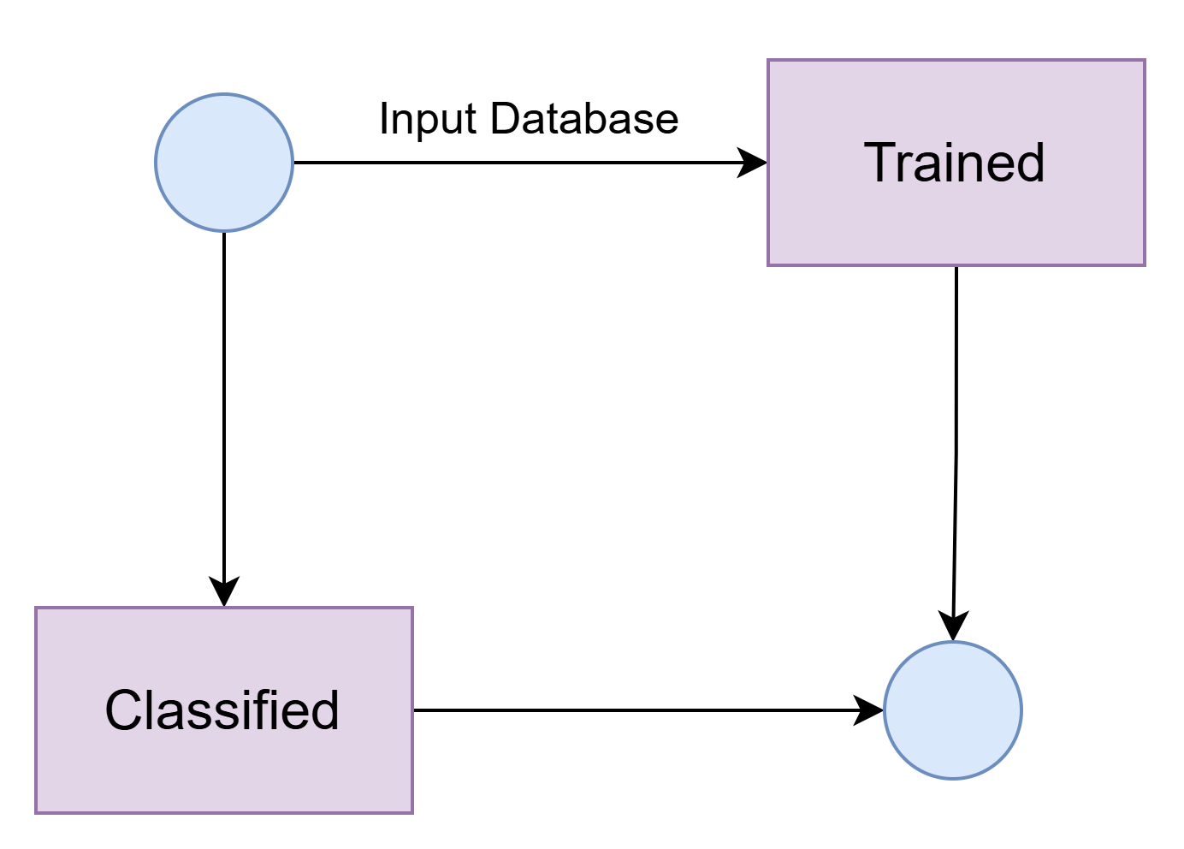

Figure 5.7: ML Model

### 5.3.8. ID: 8

**Name: Notification**

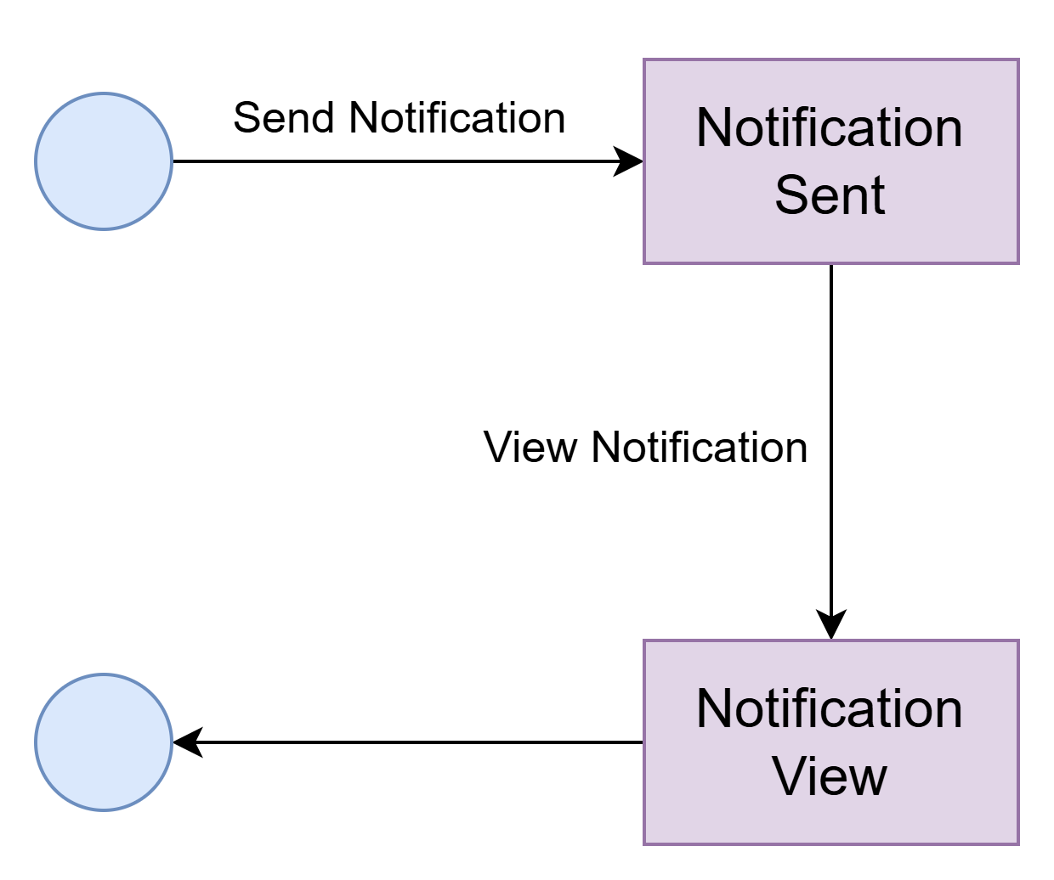

Figure 5.8: Notification

### 5.3.9. ID: 9

**Name: Dashboard**

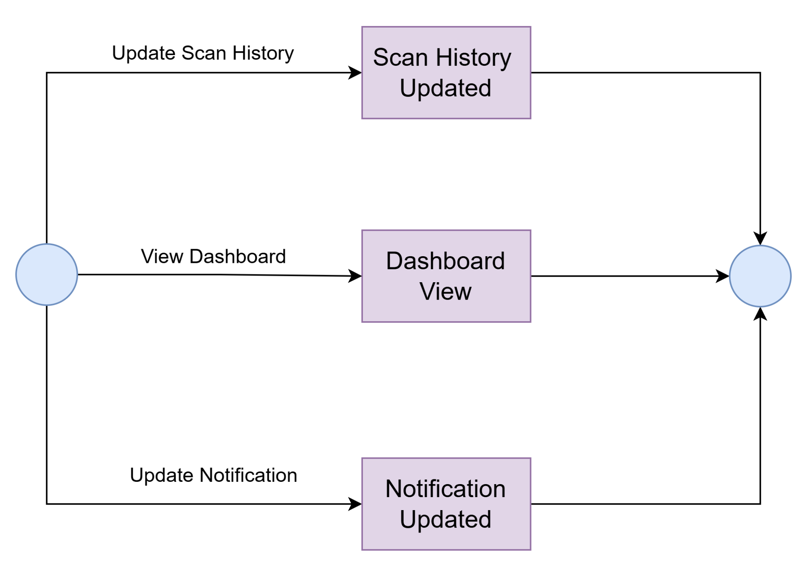

Figure 5.9: Dashboard

### 5.3.10. ID: 10

**Name****: Database**

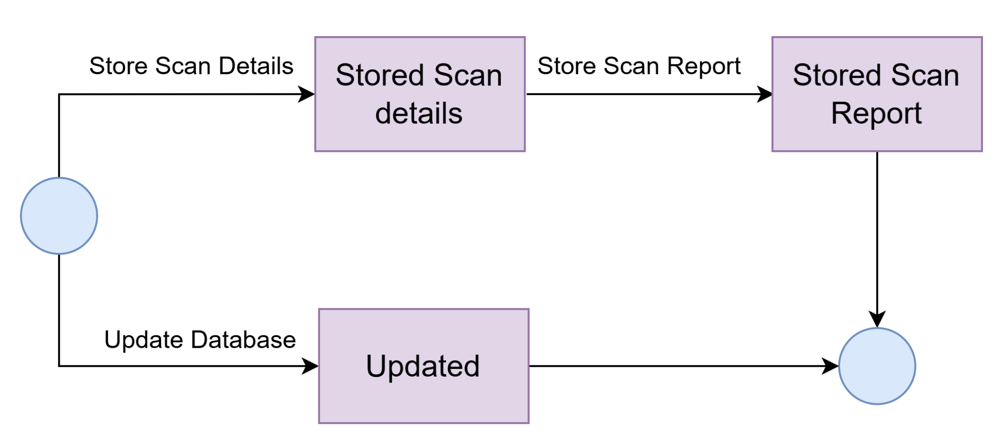

Figure 5.10: Database

# 6.Sequence Diagram

## 6.1. Concept of Sequence Diagram :

A sequence diagram is a Unified Modeling Language (UML) diagram that illustrates the sequence of messages between objects in an interaction. It is a representation of how events cause flow from one object to another as a function of time. In essence, the sequence diagram is a shorthand version of the use case. It represents key classes and the events that cause behavior to flow from class to class.

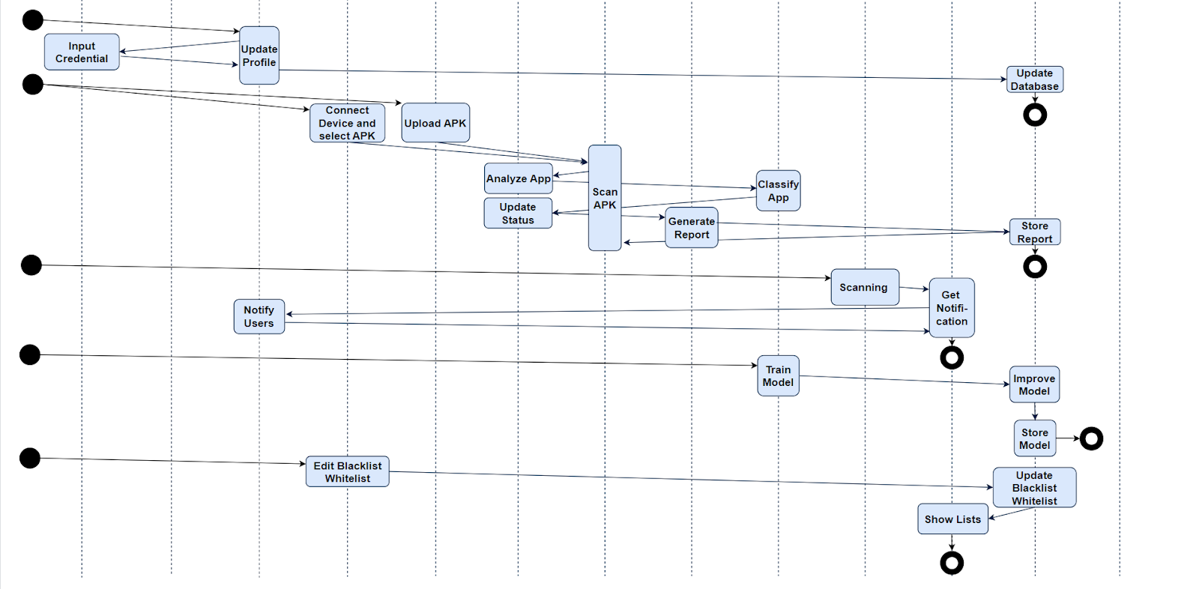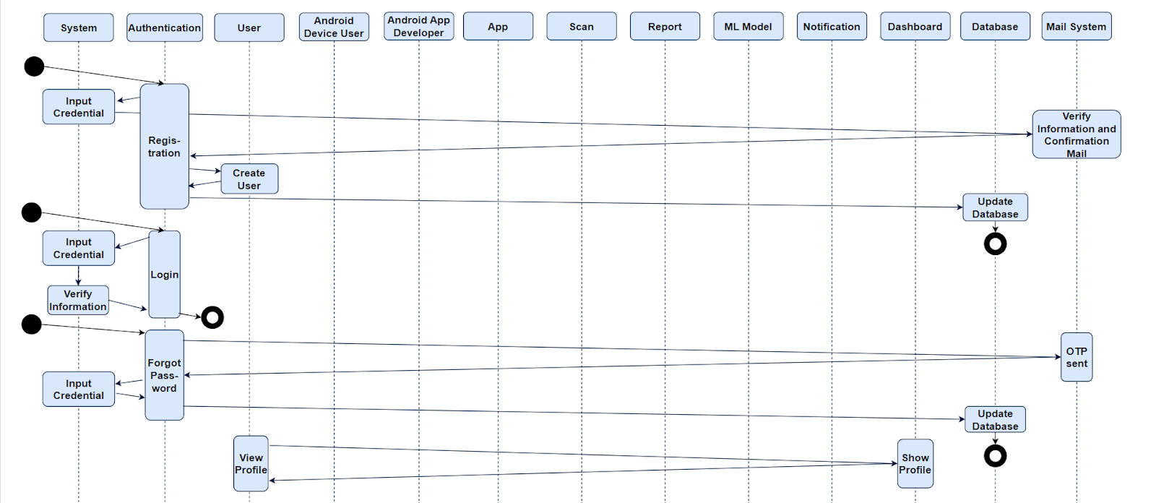

Figure 6: Sequence Diagram

**Conclusion :**

We’ve taken the time to really think about who will be using DroidScanner and how it can make their lives easier. This document is here to give everyone involved a clear picture of what the project is about and how it works.

Our main goal is to create software that simplifies app security management for both mobile app developers and everyday users. Whether you’re someone creating apps or just trying to keep your phone safe, DroidScanner is here to make the process simple and stress-free.

We’re designing this tool to be straightforward and easy to use. You won’t need to be a tech wizard to figure it out. Developers will have quick access to app security insights, and users will get clear, actionable information about the apps they use.Above all, we’ve made it a priority to listen to the people who’ll actually use this system. Their feedback has shaped how the software works and ensured it’s practical and helpful for everyone.

With DroidScanner, our aim is simple: to help people manage app security with confidence and ease.

**References:**

1. *Software_Engineering_A_practitioners_approach_by_roger_s._pressman*
2. *Sommerville-Software-Engineering-10ed*